

Supervisor:

**Prof. Nello Cristianini**

Student Number:

**2051421**

DEPARTMENT OF COMPUTER SCIENCE

An Exhaustive comparison of OCR algorithms under various conditions

A project plan submitted to the University of Bristol in accordance with the requirements of the degree of Master of Science in the Faculty of Engineering.

# Declaration

This dissertation is submitted to the University of Bristol in accordance with the requirements of the degree of MSc in Data Science in the Faculty of Engineering. It has not been submitted for any other degree or diploma of any examining body. Except where specifically acknowledged, it is all the work of the Author.

Harshit Maheshwari, September 20, 2021.

Contents

List of Figures 6

Supporting Technologies 7

Notation, Acronyms, and Terminology 8

Acknowledgements 9

Introduction 11

1.1 Evolution of Optical Character recognition 11

1.2 Importance of the topic 12

1.3 Usage of OCR 12

1.3.1 Banking Industry 12

1.3.2 Medical Sector 12

1.3.3 Finance Industry 13

1.3.4 Insurance Industry 13

1.3.5 Institutional Sector 13

1.4 Challenges to perform OCR 13

1.4.1 Hardware Issues 13

1.4.2 Character issues 14

1.4.3 Programming challenges 14

1.4.4 Unstructured Support 14

1.4.5 Font Styles 14

1.4.6 Uneven Surrounding 15

1.4.7 Language Barrier 15

1.5 Why Tesseract and EasyOCR 15

1.5.1 Community 15

1.5.2 Diverse Comparison 16

1.5.3 Common Architectural elements 16

1.5.4 High Future Scope 16

1.6 Motivations 16

1.6.1 Quality of tools 16

1.6.2 Variety of documents / Writings 16

1.6.3 Commercial Challenges 16

1.6.4 Strong Future Needs 17

1.6.5 Existing Work 17

1.7 Thesis Overview 17

Technical Background 19

2.1 Terminology 19

2.2 Neural Networks 19

2.2.1 Artificial Neural Network 20

2.2.2 Convolutional Neural Network 20

2.2.2.1 Architectures 20

2.2.3 Recurrent Neural Network 22

2.3 Long Short Term Memory 22

2.4 Image Processing 23

2.5 History of OCR tools 23

2.5.1 Tesseract 23

2.5.2 EasyOCR 23

2.6 Architecture of OCR tools 23

2.6.1 Tesseract 23

2.6.2 EasyOCR 24

2.7 Working of OCR tools 25

2.7.2 Tesseract 25

2.8 Character Error Rate 25

2.9 Word Error Rate 27

2.10 Levenshtein distance 28

2.11 Confidence Value 28

2.12 Technologies 28

2.12.1 Jupyter Notebook 28

2.12.2 Matplotlib 29

2.12.3 Pillow 30

2.12.4 Open CV 32

Project Execution 33

3.1 Project Management 33

3.2 Approach 33

3.3 Experimental Setup 33

3.4 Dataset 34

3.5 Input Images 34

3.6 Pre-processing Operations 35

3.7 Model Architecture 39

3.8 Comparison Methods 39

3.9 Results 40

3.9.1 Tesseract Output 41

3.9.2 EasyOCR Output 44

Critical Evolution 46

4.1 Discussion of Results 46

4.2 Limitations of OCR tools 46

4.2.1 Tesseract 46

4.2.2 EasyOCR 46

Conclusions and Future Work 47

5.1 Summary 47

5.2 Limitations 47

5.3 Future Work 48

References 49

Input Images 52

# List of Figures

# Supporting Technologies

* I used Python version 3.7 for noth the OCR tools.
* I used OpenCV computer vision library to perform all the image related tasks, such as, image processing, detection etc.
* I used git version control to keep my project files safe and secure with a track of all the updates made.
* I used various python libraries such as, *NumPy* ( <https://numpy.org/doc/stable/> ), *Pandas* ( <https://pandas.pydata.org/docs/> ), *Matplotlib* ( <https://matplotlib.org/stable/contents.html> ).
* I used licenced version of Microsoft Word as the processor to format my thesis.

All the above mentioned technologies and their usage in this thesis have been discussed briefly in section 2.12.

# Notation, Acronyms, and Terminology

OCR : Optical Character Recognition

NN : Neural Networks

ANN : Artificial Neural Network

CNN : Convolutional Neural Network

RNN : Recurrent Neural Network

LSTM : Long Short term Memory

CER : Character Error Rate

WER : Word Error Rate

VGG : Visual Geometry Group

ILSVR : ImageNet Large Scale Visual Recognition Challenge

DL : Deep Learning

# Acknowledgements

First of all, I would like to thank my mentor and supervisor Prof. Nello Cristianini for providing continuous support and motivation at every point during this thesis. He has always worked hard to keep a check on my work and to validate the findings. His immerse knowledge has not only helped me shape the style of working but has also made me understand the smarter and faster way of debugging the code.

In addition, I would like to extend my sincere thanks to all the lecturers, specifically Prof. Dave, Prof. Zahraa, Prof. Alan, Prof. Ian, Prof. Martha and Prof. Edwin, for their invaluable expertise in their domain subjects.

Lastly, I would like to thank my friends and family for their love and support throughout this academic year.

# Abstract

Optical Character Recognition or OCR is a technological conversion of images of texts, either machine written or handwritten, or scanned copies into an editable or machine-readable format for further processing. OCR has gained a lot of popularity in the last few decades and there are various tools available like Adobe, Abbyy and Rossum; just to name a few. A few open-source tools like tesseract, vision, ocropus, EasyOCR have a tremendous count of forks on Github and they lay a foundation of many other tools and frameworks available in the market. The accuracy of the image to text conversion is dependent on multiple factors like the quality of the image, tools used to carry out the process, pre-processing steps used, text category, etc. There are various constraints related to the conversion of images to digitized text as images tend to have multiple complexities, making it inefficient for machines to understand the text embedded into the image. A major chunk of OCR systems is used on character isolation. All the characters of a sentence are read individually to make it easier for the machines to understand and process the document. However, a low-resolution image makes it difficult to understand the text, which can further lead to problems like character mixing. Moreover, it is difficult to find the difference between the digits like 6 and 8 or 1 and 7, due to their writing structure. The background colour on which the text is printed also plays an important part in text recognition. Due to a lot of research, there are a variety of OCR tools available in the market with high accuracy. If the OCR tools have very high accuracy, do they differ in any way? Do different architectures give the same accuracy? Does the input image change the output for different OCR tools? This thesis goes a level up to the other previous research. Here we compare the outputs of the two most famous Optical Character Recognition engines: Tesseract and EasyOCR, by using different quality, category, and format of images.

We start this thesis by introducing OCR and then moving towards the more technical side of the research. A thorough background is covered with the introduction of all the technical terms, introduction to all the conceptual terms, history of both the OCR tools, architecture of both the OCR tools, a comparison of both the tools and the resulting experiment. We use different graphical outputs throughout the thesis to compare the results of the tools. The experiment is performed using the Python programming language due to its vast collection of libraries and api support for using the OCR tools. And the integrated development environment used is the Jupyter notebook because it gives all the necessary formatting to compare and interpret the results either graphically or numerically.

The dataset that we use to experiment consists of a collection of images from different categories of media sources with varying dimensions and the quality of text captured. Agile methodology is used as the working method for model creation and comparison throughout the project.

In terms of accuracy, the EasyOCR fails in comparison to tesseract for a clean document because of the integrated LSTM architecture above the classifier in the Tesseract engine. Moreover, tesseract has more number contributors and updates as compared to EasyOCR, updating it with technology. But for irregular and trickier documents, both the tools failed to give a satisfying performance. There is no clear winner out of the two. The thesis concludes by stating the results of the comparative study of the tools. It gives an insight into the category of tool that should be used by initially analysing the condition of the input image. It also helps to understand the commercial usage of tools according to the size of the input document. Moreover, a detailed understanding of the architecture and the steps involved in the optical character recognition of both tools is gained by the end of the project. This thesis also lays the foundation for using the other OCR tools in the market as it compares the two most popular tools having complex architectures.

**Chapter 1**

# Introduction

This chapter of the thesis gives an overview of the project, specifies the need and motivation for this project. It also clarifies the selection of the specific tools and their usage. Moreover, it states the need for the topic, its importance and outlines some of the common challenges related to the problem statement.

## 1.1 Evolution of Optical Character recognition

OCR is the procedure for the conversion of images of text to machine-readable format. Recognising the characters has been a challenging task for a long time and the roots of OCR lay back to the 1914 when physicist Emanuel Goldberg invented a mechanical hardware was used to detect text. This machine could read the text and convert it to telegraph code. These mechanical systems were very time consuming and less accurate. They used to work by recognising one character at a time, after many iterations, which made them less reliable for today’s era. Later, he also designed a search engine for documents that used to search micro filmed documents to recognise patterns. This technological tool, known as ‘Statistical Machine’, was later acquired by IBM. After these hardware models, no progress was made towards their enhancement. Later, after the development of high-capacity hardware, there were progressions made towards the research and development of OCR technologies. In 1970s, researcher Kurzweil [18] introduced omni-font OCR, which could process any printed text. Later, in 2000, OCR became available on cloud technology with worldwide access, compatible with any device. It is in the last two decades that OCR has made tremendous progress in the technological field. Due to increased accuracy and less time-consuming tools, it has gained a lot of popularity. These days the technology is accessible via APIs provided by many companies which are either open – sourced or have a defined fee structure based on the quality and quantity of documents to be converted. But even after so many years of research and innovation in the methodologies, outputs of OCR still possess errors.

Since the start of OCR systems till the present available systems, they undergo numerous calculations before the actual text recognition task takes place. The only difference is the processing time and the methods to carry the process. Today these calculations are carried out in a progressive manner, known as the pipeline. Every OCR tool has its own pipeline, which makes them different from one another in terms of speed of calculations, accuracy, efficiency, etc. A common pipeline for OCR consists of image pre-processing as the first step. Moving to binarization and page segmentation as the second and third steps. Line and word segmentation is performed as step four. As the last step of pipeline, process of text extraction is carried. The best OCR tools that are compared in this thesis work on highly complex recurrent neural network known as Long Short-Term Memory.

## 1.2 Importance of the topic

In the last 3 decades, OCR technologies have undergone a lot of research and exploration. Due to this continuous research, the market is flooded with a lot of tools to perform OCR. Due to diverse usage, these tools are available on the web based, mobile based and cloud-based platforms. According to the research carried in 2020, the optical character recognition market size on global level was estimated to be worth 7.46 billion USD due to its diverse industrial usage and time saving benefits helping corporates save a lot of capital and to reduce the unnecessary load. Over the period of 8 years starting from 2021, a compound annual growth of 16.7% is predicted. The major chunk of users are the big corporates and business owners who need a lot of automation, that is, the B2B segment [19]. This technology is not dominant only in the developed nations but is a widely used tool in the developing nations as well.

All the tools available in the market have their highs and lows, due to which it becomes important to analyse the accuracy and performance of the most popular OCR tools. Furthermore, understanding the performance according to the varied quality and quantity of input dataset will also help organisations decide the category of tool required according to their needs. The existing research being carried out are to make specific tools better and none of them is carried out to undergo a comparison of the existing models. This topic helps to identify the best available OCR tool available in the market. Moreover, it is beneficial to understand the important features of the input dataset like the quality and the quantity of images being converted to the text format, as it makes the system output dependable.

## 1.3 Usage of OCR

Due to a wide number of applications, OCR is a key area of interest for researchers. OCR technologies help to streamline and reduce manual intervention in various sectors of the industry, for example, it can be used to automate the mailing industry by reading the contact details written on the parcel. It saves a lot of human efforts, finances and time required to perform the tedious data entry tasks. Some of the major industrial sectors that use OCR technology to perform tasks in a smoother way are Banking, Medical sector, Finance industry and insurance industry.

### 1.3.1 Banking Industry

Banking Industry uses OCR in various places due to a lot of paper work involved. This industry was amongst the early stage adopters of this technology where numbers on the cheque were recognised using OCR [21]. This reduced the time required by the customers for the transactions related to cheque by a huge percentage. At present not only numbers, but the user signature, place and name are also extracted using this technology. This technology gives nearly 100% accuracy for information extracted from cheques. Another basic application of OCR is in the use of Automated Teller Machines, where the machine reads the number on the cards to fetch account details and deliver cash to the customers. After 2016, various neo banking platforms have evolved which validates the user data online with the help of OCR.

### 1.3.2 Medical Sector

Medical sector also has a lot of paper work involved, ranging from patients subscriptions to various medical records. Keeping a stack of all the historical medical data becomes a headache. OCR helps in converting all the records in the digital format, so that it can be easily accessed from any location at any time required [21]. These digital documents make it easier to get a better overview of the patients health and to diagnose any new disease. Moreover, scientists and pharmacists can store all the information related to various drugs in the digital format and can access them easily from cloud platforms whenever required.

### 1.3.3 Finance Industry

Finance professionals, charted accountants and analysts can profit substantially from OCR technology since it allow them to focus on high-priority activities rather than processing data using outdated ways. Filing income tax returns at the year end becomes very hectic due to lots of hard copies of bills, expenses and other assets. Digitizing these documents can save a lot of time for financial planners and tax payers as it makes documents, bills and other financial statements error free. It can also be used to keep a track of all the bills and other financial documents for future references.

### 1.3.4 Insurance Industry

Insurance industry is no exception when it comes to lengthy hardcopies and tremendous amount of manual paper work. To give better costumer experience, insurance companies have now started to make customer onboarding easier and faster using OCR technology by extracting essential verification information from the documents uploaded by the user. These documents are stored in digital format which not only helps the companies with easy storage and anytime access but also helps the customers in claiming their insurance without any hardcopies.

### 1.3.5 Institutional Sector

Institutions hold a lot of old books, newspapers, and other important documents. OCR can also be used to archive millions of these documents so that they can be easily accessed online and can also be preserved [20]. This also reduces the physical space taken by these old books. Moreover, this online repository also helps institutions gain worldwide visibility in the field of their research and inventions. These digitized documents can also be used by various professionals to provide their input in the research and development being carried by institution or within the institution. This mix of inputs from individuals from various professional backgrounds helps in getting better and unique ideas to choose from and get higher research outcomes. The digitized papers and journals also help the students get the originally structured methodologies and techniques designed by the researchers.

## 1.4 Challenges to perform OCR

Implementing OCR tools has always been a challenging task as the domain requires a lot of research and knowledge to perform even a small task. Due the continuous evolution in this technology, it is crucial to understand the basic architecture of the tool as the output results are heavily dependent on the working of the tools. Since the technology is being worked upon since a few decades now, getting the detailed overview of the architectural evolution becomes difficult. The exponential growth in the neural networks has been the backbone of the growth of OCR tools but has also created a need of good quality hardware to run the algorithms working behind the tools being compared, as they are big and heavy on machines.

### 1.4.1 Hardware Issues

The dataset utilized for this work is entirely made up of photos, placing it in the category of big data and necessitating a large amount of storage space. Working on a small laptop for OCR tasks is time-consuming due to the large dataset. Furthermore, even if the algorithms are implemented on more powerful hardware for faster output, the problem of overheating persists. On the technological side, there are several limits, as the machinery necessary to deploy present OCR technology quickly is expensive and still requires a lot of research.

### 1.4.2 Character issues

Unicode contains a large number of symbols and characters, and OCR machines aren't trained to recognize them all, making document evaluation challenging. This has a significant impact on OCR tool accuracy, as accuracy can be very low in character-rich documents but very high in others.

### 1.4.3 Programming challenges

The tools are written in different programming languages and supports specific versions of programming languages. These versions are dependent on the time and supporting architecture when further development of these tools was stopped. Python programming language is used to perform OCR in this project, but different tools support different versions of python programming which makes it challenging to understand the syntax difference as well as to setup different environments for all the tools to be compared. According to GitHub, the percentage of languages used in creating the models for individual tools has been shown in figure 1.

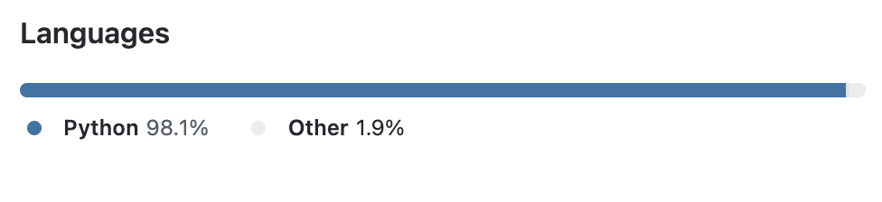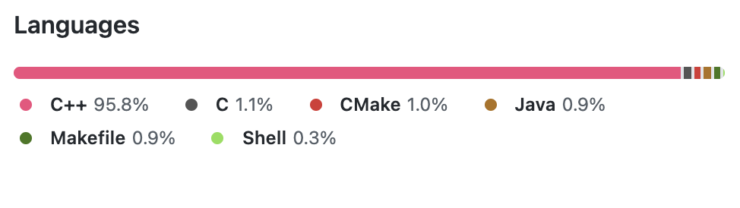

EasyOCR :

Tesseract :

### 1.4.4 Unstructured Support

One of the most challenging and time-consuming tasks is to understand the implementation of the OCR tools as they have minimal documentation support. This is majorly because the tools have evolved overtime from a less accurate basic structure to a complex and better performing tool. These complex structures have multiple supporting researches to support the development of newer tools.

### 1.4.5 Font Styles

There are various font styles in which the scripts can be found. These fonts can have variations in between the characters, which makes it difficult to perform the segmentation task. Moreover, the characters of different fonts also have patterns which makes it furthermore difficult to recognise characters.

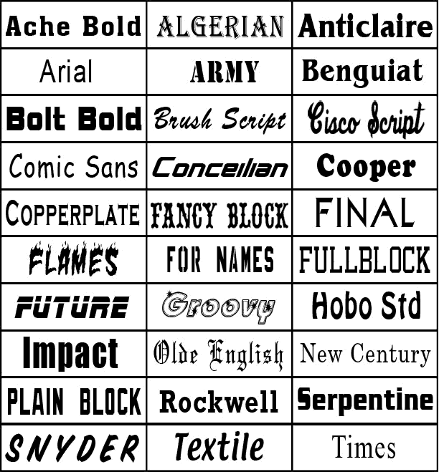

### 1.4.6 Uneven Surrounding

The pictures can be taken in different environments and so the quality of the image might change depending on the surroundings. Due to these uneven surrounding conditions, the picture might be angled, skewed or tilted. This leads to degradation of the required characteristics of the image which in turn impacts the output of the OCR tool. This challenge in majorly encountered in the images captured using a camera and not in the case of the scanned images.

### 1.4.7 Language Barrier

Languages also play an important role in the performance of the tool and possess heavy challenges for computation. Simple English text can easily be converted but when it comes to tougher languages like Chinese, Arabic, etc. OCR systems tend to fail due to the style of writing and difficulty to divide the sentences into words and characters. Typographic errors also make the conversion challenging. These errors can be due to the italics style writing, background colour error, errors due to the size of font etc. All these aspects make performing OCR challenging and difficult. And due to these challenges, the accuracy of OCR tools is not 100% and requires human intervention to complete any task.

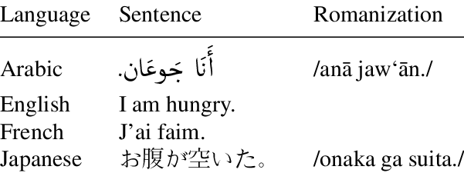

## 1.5 Why Tesseract and EasyOCR

Out of n-number of available OCR tools in the market, this research specifically focuses on the Tesseract and EasyOCR. This selection is made by taking into consideration a few parameters such as the diversity of the community involved in usage and development of these tools, the common architectural elements and their future scope of research.

### 1.5.1 Community

The open source community of all the three mentioned tools is large and active. Taking into account the large fan base, these have a very diverse community from across the globe. The size of the community can be easily measured by looking at one of the most common version control software, Github. A star rating of 41.6k with over 45 releases in last 13 years makes Tesseract one of the most popular OCR tool. EasyOCR comes on second with 12.4k stars and is not as popular as tesseract because it is a newly developed tool but has shown an exponential growth with 14 releases in just 2 years.

### 1.5.2 Diverse Comparison

Tesseract is considered to be a very old tool with a long history of heavy evolution in multiple stages whereas EasyOCR is quite new and does not have much evolving elements. This makes the comparative research more deep and gives a chance to understand the growth in the changes made in the architecture with the specific reasons and results of those changes. Also, it helps in finding the difference in the performance of an older tool with a modern tool.

### 1.5.3 Common Architectural elements

All of the three tools use specialised recurrent neural network – LSTM as there base extractor, making them very advance and complex technology. This architectural element not only gives a better accuracy but also gives them a wide angle for integration of different models to support their future growth.

### 1.5.4 High Future Scope

These tools hold a good amount of work that can be carried out in future to make them more accurate and reliable. This gives a scope for this research to be carried forward and create a reference for future researches/work being done on the these tools.

## 1.6 Motivations

There are lots of factors that play a crucial role in building the motivation to select this specific research topic. These include the quality of OCR tools available in the market, variety of documents and the commercial challenges involved.

### 1.6.1 Quality of tools

With the advancement in technology and a wide research in the computer vision and neural networks, OCR tools available in the market have gained a lot of popularity. Due to diverse usage and increased demand, there has been a significant rise in the number of tools available. This has resulted in creation of various tools with low accuracy and improper quality of analysis.

### 1.6.2 Variety of documents / Writings

Since centuries, writings have been considered to be a consequence of cultural diffusion originating from the Mesopotamian civilisation from the early Bronze era. After multiple discoveries from various regions of the world, it has been confirmed that the origin of writing is not from one region or century rather there were multiple origins. These writings had varied structures and form, which ultimately gives a solid evidence of having multiple independent origins. With the continuous evolution from writing on stones to writing on paper and in recent times, with the advancement in technology, going paperless has become a new mantra. This lead to creation of billions of document types with varied writing styles. Converting a good amount of text from various image types having different structure and language style is a challenging task.

### 1.6.3 Commercial Challenges

In various work places, a vast amount of time is spent on unwanted tasks such as sifting through stacks of documents, performing manual entries, organising bills, matching documents etc. Due to these unproductive tasks, the demand of OCR technology is increasing in every domain of the industry. With the technological evolution and increased demand, there are various OCR tools available in the market and it becomes difficult to choose the best one according to the structure, quality and the quantity of the document.

### 1.6.4 Strong Future Needs

The growth and need of optical character recognition in every sector of the industry has been mesmerizing, but it is important to understand that OCR is not just required for the conversion of analog text to digital format whereas it has usage far beyond. It can be further used to generate insights and useful results there is still a need for a lot of research in this domain.

### 1.6.5 Existing Work

Even after having many use cases, there are very less optical character recognition tools available to convert images into text in the market for free. The available OCR tools have their own set of steps to implement them on different images dataset. Due to these differences, the metrics used for evaluating the performance of these tools in dependent on multiple factors and vary according to the implementation and the results of the tool.

In terms of existing comparisons and predictions, Vijayarani [11] lists few of the common OCR tools available online for free, to compare their performance on the basis of accuracy and word error rate. She talks about text types and their performance issues while applying the conversion task. Her result specified that the OCR tools were not able to detect and convert the symbols and different kinds of font involved into text. The outputs in that space were usually blank.

Shivani [12] talks about the two open source OCR tools and compares them on the basis of two different parameters accuracy and precision. She told about the difficulty of comparing OCR performances for the handwritten images and takes into consideration only the printed documents. Their results specified that the tesseract out performs Google OCR for most of the documents but lags in some cases.

Marcin [13] compares the OCR tools amongst the highest market share holders. They highlight the importance of training the models to increase the performance of both the tools. Their comparison results marked the competitiveness in the OCR tools available.

## 1.7 Thesis Overview

This thesis comprises of 5 chapters. These chapters are arranged in an easy-to-understand order. The first chapter gives the introduction of the whole thesis starting from the basic definition of OCR to its use-cases. The second chapter covers all of the technical concepts which are essential to experiment successfully. These concepts start from the basic architecture of the tools being used to their practical working. The third chapter carries all the execution part. In this, all the essential coding for both tools is done to implement the research. This section discusses the hurdles that arise in the execution and how those hurdles were solved to implement the OCR. The fourth chapter outlines the comparison of the outcomes of both tools. It categorises the tools according to their performance and accuracy. The last chapter lists the outcome of the experiment, with final results and gives a summary of the project. Due to continuous evolution in the OCR technologies and there is increased usage, this thesis also includes the scope of the future works that can be carried out using this research as a reference. Moreover, it also states how this research can also be extended to compare other commonly available and famous open-sourced OCR tools with comparable fan base and availability in the market. Finally, a reference list of all the resources used to carry out this research is attached, so as to give a better understanding and reliability to this project.

**Chapter 2**

# Technical Background

This chapter of the thesis introduces the concepts related to the OCR tools that are compared. It starts with important terminologies and a brief introduction of neural networks which form the base of the OCR tools. Then it moves towards the Recurrent neural network, which is a specific category of neural network used for our tools. Finally, it gives a brief history of both the tools followed by their architectural overview and working.

## 2.1 Terminology

**Pixel.** A pixel is the building block of an image. These pixels are responsible for given different colours to the image as they are made of variable intensities. A resolution of 1920 * 1080 pixels resembles that there are 1920 pixels in every row of the image and 1080 pixels in every column of the image. The more the pixel density, the better is the image quality.

**Binary image.** A binary image also called a two-segment or bi-segment image is an image that consists of only two colours, black or white. This means that the image consists of only two types of bits: 0 or 1, hence the pixels will be stored as either 0 or 1. It is a very common term in image processing and

**Grayscale image.** A grayscale image, also known as a grey monochrome image, is made up of only shades of grey. It is different from black and white images as it consists of all the shades of grey and not just black and white colours.

**Digitized image.** It is an image that is converted into a format that can be used as an input to the machines.

## 2.2 Neural Networks

The brain is the most complex segment of the human body. Numerous studies are going on to understand its structure and working. Due to its vast abilities and small size, it attracts a lot of research and study. The beginning of neural networks, in artificial intelligence, to mimic the functions of a human brain through different sets of algorithms was marked by McCulloch and Pitts in 1943 (Hardesty, 2017) [1]. The roots were laid to solve computational problems in a way similar to the human brain. Later, with the advancement of technological hardware and reduction in cost, these were used to perform a variety of tasks. They carry a lot of importance to solve day to day problems with multiple types of complexities. These networks are made up of neurons that resemble the biological neurons in the brain cells and are used to perform complex tasks. There are majorly three types of neural networks known as the artificial neural network, convolutional neural network, and recurrent neural network.

### 2.2.1 Artificial Neural Network

Artificial Neural Network, commonly known as Feedforward Neural Network, is considered to be the simplest division of neural networks as it consists of a group of neurons working in a single direction. Its roots lay back to 1958 when psychologist Frank Rosenblatt invented the Perceptron to corelate it with the human brain (Rosenblatt, 1958) [2]. It does not perform well on image data as it takes input only in one dimension, which means that the images are required to be converted into one dimension. This conversion not only increases the parameters of the input but also removes the features of the image. Hence, ANN cannot function well for image data.

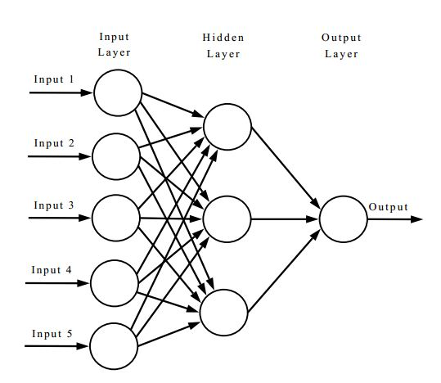

Figure 1 Artificial Neural Network

### 2.2.2 Convolutional Neural Network

Convolutional Neural Networks are generally used for visual tasks. There were many different models introduced to recognise patterns similar to the way a human brain recognises but all of them had distortion and positioning issues. The famous ones include a three-layered perceptron introduced by Frank Rosenblatt in 1962 [4] and a visual information processing model given by M. Kabrisky in 1966 [5]. In 1980, Kunihiko Fukushima, a Japanese computer scientist, talks about the self-organising ability of these neural networks to recognise patterns and calls them neocognitron [3]. The building blocks of CNNs are known as kernels. It easily captures the data from an image and finds the relationship between the individual pixels of that image. This helps in dividing and identifying different aspects of the image. The major drawback of this network is that it becomes slow when the number of hidden layers is increased. Moreover, it is very complex to build if the dataset has varied features.

### 2.2.2.1 Architectures

There are various traditional architectures for CNNs that have similar general principle of stacked layers of networks whereas the newer architectures try to find a more reliable and faster network layer to build CNN. Almost all of these networks follow the same design principles for the input. The famous LeNet5, introduced to recognise the handwritten digits by Yann Lecun et el in 1998 [6] is the historical CNN architecture which is trained on 60000 images dataset.

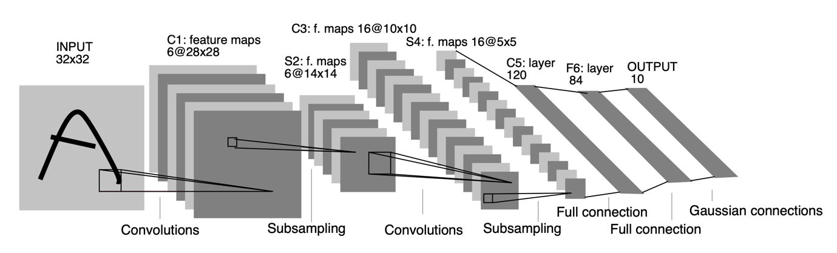

Figure-2 LeNet-5 architecture for digits recognition

The AlexNet architecture is based on the LeNet-5 architecture and was developed in 2012 by Alex Krizhevsky et al. to compete in the ImageNet competition [28]. The architecture of AlexNet was designed to understand much complex objects and hierarchies. Due to this complicated structure, the time required to train the model was increased a lot. To reduce the training time, it was trained on GPU as the number of cores in the GPU are much larger than a CPU. This architecture resulted in better image recognition, ultimately giving better OCR outputs.

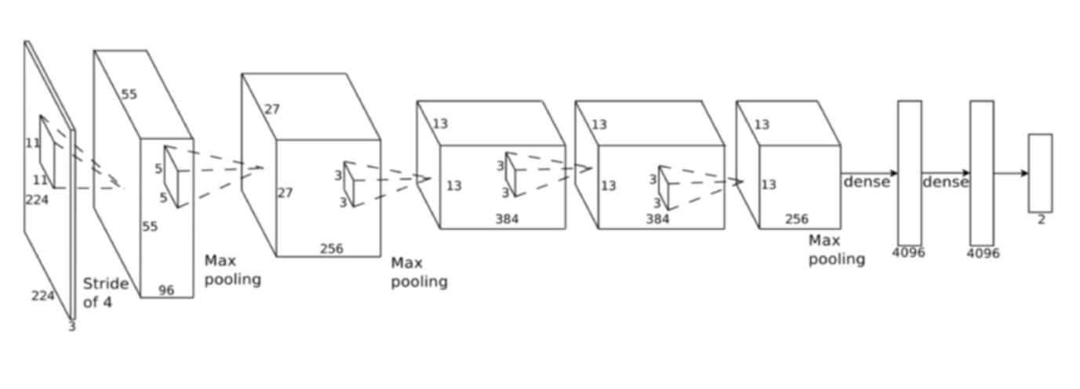

Figure-3 AlexNet Architecture

VGG16 is a more advanced neural network proposed by two computer vision researchers at the University of Oxford in the paper “Very Deep Convolutional Networks for Large-Scale Image Recognition”.

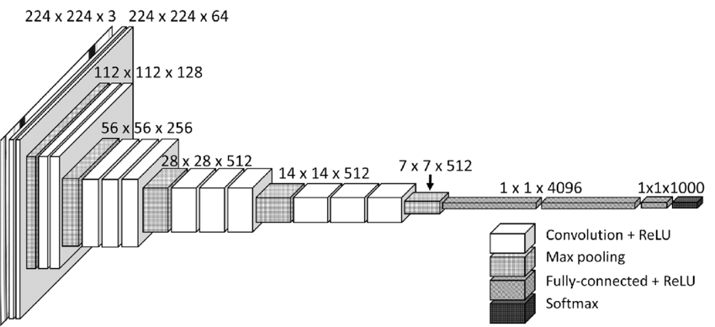

Figure 4 VGG16 Architecture

### 2.2.3 Recurrent Neural Network

Recurrent Neural Networks are built on artificial neural networks. A special type of RNN known as Associative Neural Network was first introduced by J. Hopfield in 1982 [7]. These networks can remember the sequence of inputs in their attached memory to improve their predictions. RNNs are computationally less expensive because they receive input from the previous layer, allowing them to perform predictions with less input data. It could be a difficult task to train and process long sequential data in a recurrent neural network.

All the three categories of neural networks are used for different purposes since they all have varying structures.

## 2.3 Long Short Term Memory

A very popular kind of gradient based Recurrent Neural Network known as Long Short Term Memory or LSTM was introduced by Hochreiter and Schmidhuber in the late 90s to solve the problem of information storage over extended time intervals by modifying the gradient [8]. It is a neural network that is much more advanced than a feedforward neural network. The main goal of creating LSTM was to increase the accuracy of RNN models and to solve the problem of long-term dependency.

Every LSTM unit consists of a memory cell which can store information for a specific duration of time. The LSTM architecture includes three gates: the input gate, the output gate, and the forgotten gate, which are in charge of information retrieval, storage, and deletion. The input gate decides the quantity of data to be stored from the previous layer. The output gate decides the quantity of data that should be sent out to the next layer. And the forgotten gate decides when the data should be removed. There are various kinds of LSTM models used with slight variations. A famous LSTM version was introduced by Gers & Schmidhuber in 2000, in which the state of the cell can be examined by gate layers. Another variation was introduced by connecting input and forgetting gates, where the judgments are made collaboratively rather than individually determining what to leave out and what to add. A model that is easier to understand than an ordinary LSTM model, known as the Gated Recurrent Unit, was introduced by Cho, et al. in 2014.

## 2.4 Image Processing

In simple terms, image processing can be defined as the process of enhancing the image for various kinds of information extraction. There are mainly two methods used for image processing, namely, analog image processing and digital image processing. The analog image processing method processes hard copies or physical images. Whereas, the digital image processing method processes digital images, that is, images stored on computers or other electronic devices with the help of various computational algorithms. There are a number of open-source image processing libraries available on the market, the most popular of which is OpenCV, which contains a number of libraries that are required for image processing tasks.

## 2.5 History of OCR tools

### 2.5.1 Tesseract

The Tesseract is one of the most popular tools used for Optical Character Recognition. Its investigation was a research project that began in 1984 at Hewlett Packard Labs in Bristol and lasted until 1994. Some critical changes were made to the port's windows in 1996. In 2005, Tesseract was open sourced by Hewlett Packard and, since 2006, Google has been the lead sponsor for the development and testing of Tesseract. Version 4 of Tesseract was released in 2018, with a major update to the integration of the LSTM based recognition engine.

### 2.5.2 EasyOCR

EasyOCR is a modern character recognition library released in July 2016. It is created in the name of a private organisation, which specialises in AI, registered as JaidedAI by using multiple research papers and open source code repositories with an aim to build a better performing character recognition tool. It is regarded as one of the easiest to use character recognition tools amongst available high accuracy tools. With the latest version released in 2021, this library supports 80+ languages which includes the most difficult writing scripts such as Chinese, Devanagari, Latin etc. The library is most suitable for python users as it is written in python with complete deep learning segment in Pytorch.

## 2.6 Architecture of OCR tools

### 2.6.1 Tesseract

The architecture of the Tesseract is a combination of 5 different segments. The first segment consists of Adaptive Thresholding, wherein the image is converted into its binary version. In the second segment, known as page layout analysis, the character outlines forming the individual blocks are extracted from the converted page. In the third segment, which is commonly known as the line recogniser segment, the outlines of the text are recognised and are converted to blobs. These are further divided into words by understanding the area or text size. The last two segments are used for the word recognition task. The first segment performs word recognition using a simple classifier. The words which cross a threshold level are recognised and saved as a training dataset for the classifier. Using this dataset, the second segment looks for the remaining words which were not recognised in the previous segment.

Adaptive Thresholding

Line Recognizer

Page Layout Analysis

Word Recognition 1

Word Recognition 2

Figure 6: Architecture of Tesseract

### 2.6.2 EasyOCR

The architecture of EasyOCR consists of multiple different segments taken from several research papers. The first segment known as the Detection part is based on Character Region Awareness for Text Detection or CRAFT framework. This framework was introduced by Baek et al. in 2019 with an aim to overcome the problem of character level annotation [9]. It is designed by using batch normalisation over the VGG16 architecture which is a convolution neural network. It gives two separate outcomes as the region score and the affinity score. The region score determines individual character level localisation while the affinity score is used to create a single instance by using each character. Figure 6 illustrates the schematic overview of the CRAFT framework with output scores.

The second segment known as the recognition model is based on Convolutional Recurrent Neural Network. This model was proposed by Shi et al. in 2017 to solve the problem of scene text recognition, which is amongst the most important image based sequence recognition [10]. This segment is a combination of three different modules, namely, feature extraction module, sequence labelling module and decoding module. The feature extraction module uses the resnet architecture so as to make it easier to train the deeper networks. This architecture was introduced by assembling the residual functions with reference to the input layer by removing the unreferenced residual functions from learning (He et al., 2015) [15]. The sequence labelling module is based on the LSTM. And the last, decoding module, uses the novel method of training the recurrent neural networks which works on the existing neural network classifier and its principles (Graves et al., 2006) [14].

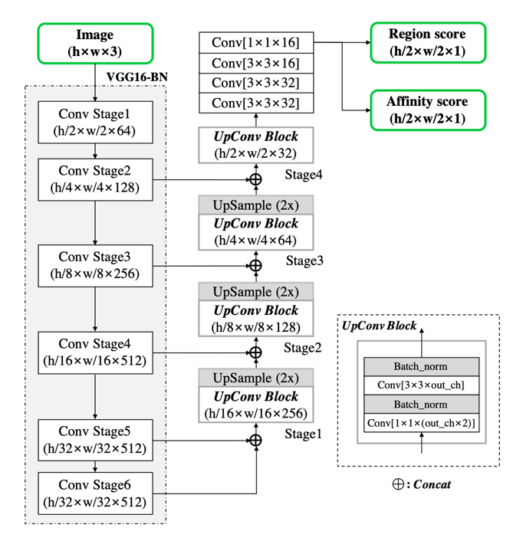

Figure-7 CRAFT Architecture

## 2.7 Working of OCR tools

### 2.7.2 Tesseract

## 2.8 Character Error Rate

Character Error Rate is a heavily used performance metrics to calculate the machine translation systems majorly OCR.

Character Error Rate can be calculated as:

$$Character Error Rate = \frac{S_{c} + D_{c} + I_{c}}{N_{c}} = \frac{S_{c} + D_{c} + I_{c}}{S_{c} + D_{c} + C_{c}}$$

where:

|  |  |  |
| --- | --- | --- |
| Variable | Meaning | Example |
| Sc | Number of substituted characters in the output. | ‘123490’ gets extracted as ‘1Z349O’, which means, ‘2’ and ‘0’ gets substituted as ‘Z’ and ‘O’. |
| Dc | Number of deleted characters in the output. | String ‘ABC1234’ gets extracted as ‘AC123’. Here ‘C’ and ‘4’ are deleted and not present in the output. |
| Ic | Number of inserted characters in the output. | A series of characters ‘94127’ gets converted into ‘g41Z’ at the output . Here, one character is missing which needs to be inserted to compare with the ground truth. |
| Nc | Total number of characters in the ground truth excluding the inserted characters as initially they were not available. |  |
| Cc | Number of correctly extracted characters in the output. | Sum of all the correctly extracted characters. |

The percentage of characters in the ground truth that were predicted inaccurately in the OCR output text is the result of this equation. The performance of the OCR is justified by the value of the CER as, lower the value of CER, better is the performance of the tool.

It is common to see a CER value crossing the 100% mark when the reference text size is large but the mistakes in the output are larger, or majorly when the number of time the insertion operation performed is high. To bring the value of CER in the range of 0-100%, a normalisation technique is used. The number of mistakes can be divided by the summation of the number of number of correct characters and the number of edit operations.

The normalised equation can be stated as:

$$Normalised Character Error Rate = \frac{S_{c} + D_{c} + I_{c}}{S_{c} + D_{c} + I_{c}+ C_{c}}$$

Another important consideration made while calculating the CER are the blanks or white spaces as they play a crucial role in separating the words and making a meaningful sentence. Example, mangoes and man goes have a completely different meaning. Generally multiple white spaces are considered as one during the calculation.

There are various theories that define different ranges of CER value for a good OCR output. These values vary according to the structure of the document, quality, type of content, writing style of the text etc. A common reference taken to resolve this conflict and to set a benchmark for the newspaper style dataset is taken from an article from the Australian Newspaper Digitization Program (Holley, 2008) [16]. These benchmarks were:

* Poor OCR accuracy: The character error rate > 10%
* Average OCR accuracy: 2% < character error rate < 10%
* Good OCR accuracy: 1% < character error rate < 2%

These benchmarks are not valid for hand written text as it is very difficult to get consistency and the content can be a combination of symbols and out to vocabulary words. A character error rate of 20% can be considered as a satisfactory level for hand written data set.

## 2.9 Word Error Rate

Word Error Rate is another most widely used performance metrics to measure the machine translation systems. A common problem in calculating the performance of the OCR systems is that the recognised word can have different word size when compared with the ground truth. Calculations involved in WER are based on the Levenshtein distance. This approach cannot be directly implemented because of one of the important drawback that it does not provide with in-depth conversion errors which makes it difficult to understand the required changes to get higher accuracy of the OCR tool. A better approach to use WER as the performance metrics is to align the words that are recognised in the order similar to the ground truth and then perform the calculations. Character Error Rate and Word Error Rate are calculated using the same formula with the difference that the WER is applied on words and CER get in more granular and is applied on the character level. Word level is generally used with the data that has meaning, like paragraphs in a newspaper.

Word Error Rate can be calculated as:

$$Word Error Rate = \frac{S_{w} + D_{w} + I_{w}}{N_{w}} = \frac{S_{w} + D_{w} + I_{w}}{S_{w} + D_{w} + C_{w}}$$

Where:

|  |  |  |
| --- | --- | --- |
| Variable | Meaning | Example |
| Sw | Number of substituted words in the output. | ‘Vitamin’ gets extracted as ‘Vltamin’, which means, ‘i’ gets substituted as ‘l’. |
| Dw | Number of deleted words in the output. | In sentence ‘World needs to control pollution’, ‘needs’ does not get extracted due to inefficient tool. |
| Iw | Number of inserted words in the output. | The word ‘Mangoes’ gets converted into ‘Man goes’ at the output. Here, the meaning of the word gets completely changed when compared with the ground truth. |
| Nw | Total number of words in the ground truth excluding the inserted words as initially they were not available. |  |
| Cw | Number of correctly extracted words in the output. | Sum of all the correctly extracted words. |

However, one disadvantage of adopting a general formula as stated above is that it ignores the impact that different sorts of faults may have on the likelihood of a successful conclusion, for example few errors can be heavier than others and few can be easy to remove. Moreover, it becomes difficult to segregate the errors by sum of deletion and insertion error from the substitution error. Thus, it is advised to derive a formula according to the problem to get the best accuracy calculations. For example, A new formula to calculate the word error rate was introduced by assigning different weights to the errors.

$$Weighted Word Error Rate = \frac{S_{w} + {0.5 D}_{w} + {0.5 I}_{w}}{N_{w}}$$

## 2.10 Levenshtein distance

Levenshtein distance is a string metric that is used to compare two string sequences. In other words it is the smallest number of required edits done on individual characters (insertions, deletions, or substitutions) to transform one word into the other. This distance is named after a Russian scientist and mathematician Vladimir Levenshtein, who used this distance metric in 1965 [17]. The distance computed between the two strings a,b having a length |a| and |b| can be given as:

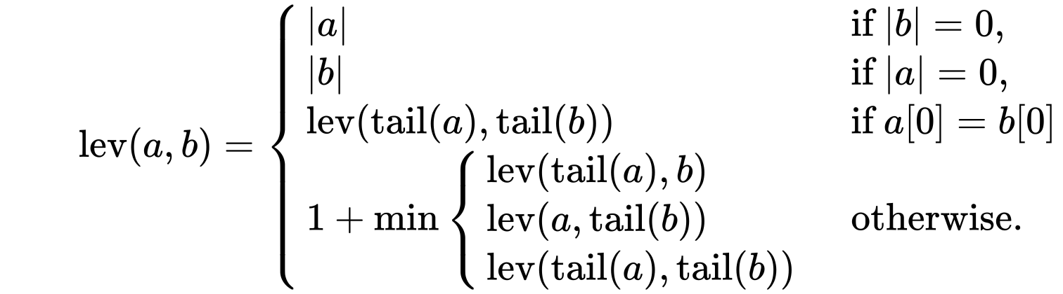

where the tail of some string x is a string of all but the first character of x, and x[n] is the nth character of the string x, starting with character 0.

There are various upper and lower bounds for the Levenshtein distance which can be described as:

* For the two strings, it is at least the size difference between them.
* The highest distance should not be greater than the length of the longer string.
* If the length of the strings are equal, the distance is zero.
* The Levenshtein distance follows the triangle inequality law, that is, the sum of distance between the two strings should not be greater than the sum of Levenshtein distance from the third string.

## 2.11 Confidence Value

The error rates calculated help in predicting the confidence value for any OCR to evaluate its performance. These values are further used in industries to define a threshold value and to get an understanding of certain processes that can be automated end-to-end and those which require human interaction wherever needed throughout the process.

This can be easily understood by taking into consideration certain scenarios. For example, a pharmaceutical company involved in analysing the drug information from the label might need to introduce a lower threshold value so that it can introduce human interaction in the process for the granular verification of the data for the labels that qualify that threshold value. It is important to do this because incorrect information extraction from the drugs label can cost a lot of lives.

A second scenario can be considered where a loan application company needs OCR for the document processing task. It can set a medium confidence value threshold as human interaction will only be required to have an overall glance at the application.

## 2.12 Technologies

There are various technologies used for the implementation of this project. It is majorly due to wide usage of latest technological support required for the execution of the OCR algorithms.

### 2.12.1 Jupyter Notebook

It is a free, open source integrated development environment used to create coding files which can be easily shared with other users through platforms like GitHub, Dropbox etc. It There are many IDEs since decades for computational tasks but Jupyter Notebook is one of the most popular one because of its ability to supports more than 40 coding languages which makes it a good choice for a wide community of developers.

This is the best IDE for the OCR projects because it can be easily integrated with big data technologies like Hadoop and Spark by simply using the common programming language, Python.

Moreover, Jupyter Notebook provides beautiful and interactive visualisations essential for any Data Science project. The best part of using this IDE is that a user can write a line of code and see what happens by that code immediately in the next line. This provides an interactive approach towards data visualization and gaining insights. It also helps in debugging and modifying the code easily as the execution process takes place line by line.

According to Dr. Jeffrey M. Perkel, there were more than 2.5 million jupyter notebooks available on the code sharing platform GitHub in 2018 [22].

### 2.12.2 Matplotlib

It is an open source python library used for creating data visualisations and plotting graphs. It is a cross platform library built over NumPy and is an alternative to MATLAB. It is written in such a way that a few lines of code can easily create great plots. It was written by J. Hunter with many other contributors marking an initial release in 2003 [23]. It gradually become the most widely used visualization tool amongst scientist worldwide. It provides APIs to connect with other third party tools which can be further used for interactive developments. There are various plots supported by matplotlib, some of the common ones are:

* Line Plot: Simple Line plots illustrated in figure 8a can be created by using the *plot( )* function provided by the matplotlib library.
* Sub-plot: One of the easy-to-compare feature that matplotlib supports is the creation of multiple subplots by using the *subplot( )* function. This feature helps in comparing multiple plots in a single cell as shown in figure 8b.
* Images: It is important to analyse images dataset for this project. Matplotlib provides easy display of images by using the *imshow( )* function.
* Histogram: Histogram plays in important role for analysing big datasets. Matplotlib provides with *hist( )* function to create histograms and get bin counts.

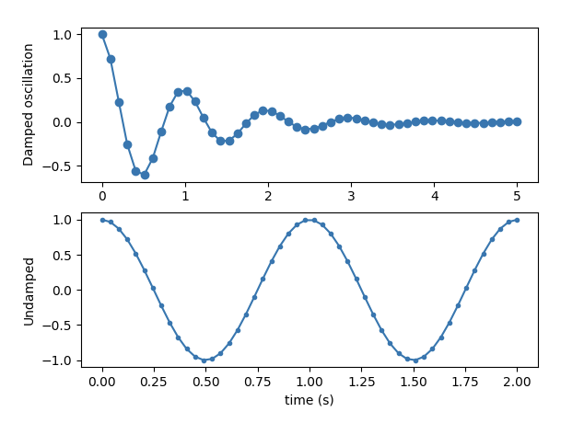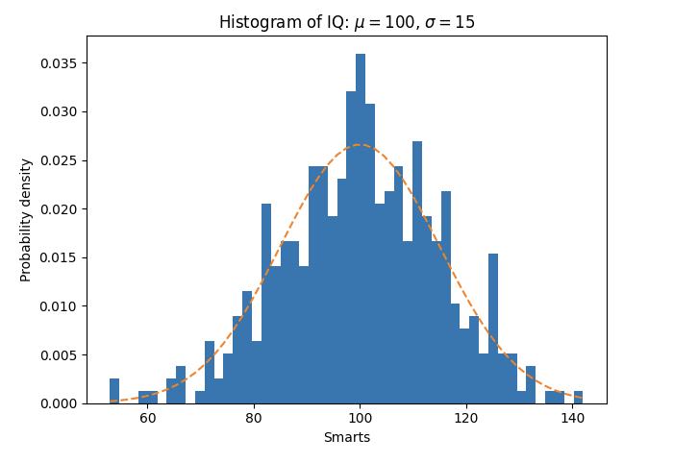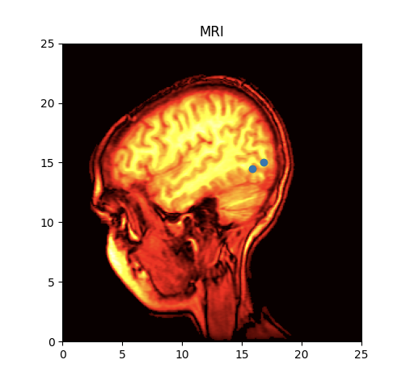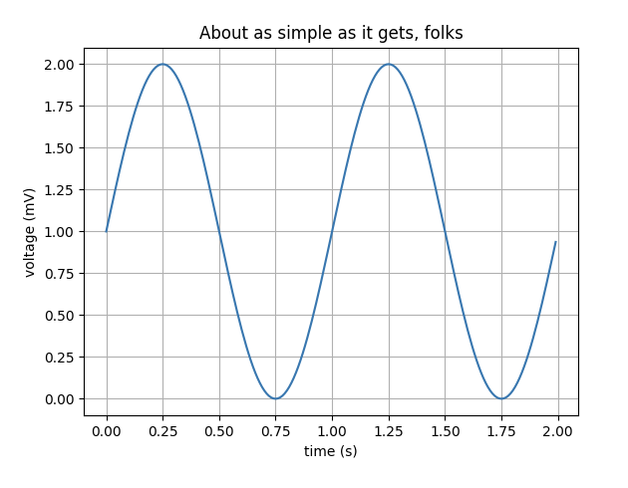

Figure 8 – Some of the most commonly used plots created using open sourced MATPLOTLIB

(c) Image

(d) Histogram

(a) Line Plot

(b) Sub-plot

### 2.12.3 Pillow

It is the most widely used python library for image processing tasks. It is important to understand different image types as the image type can heavily influence the OCR output.

Some the major file types that are supported by this library are:

* BMP (.bmp): Bitmap Image File format is a raster graphics file format used to store two dimensional images which can be monochrome as well as coloured. This image format is device independent and can easily display images on windows or mac without the use of any external graphics adapter.
* EPS (.esp): Encapsulated PostScript is a file format that was created by Adobe in 1992 essentially for vector images. It gained popularity amongst designers due to its ability to get resized without any loss of details.
* GIF (.gif): Graphics Interchange Format is the most widely used format of images over the social media platforms across the globe due to their support on any kind of device. This format was released in 1987 by an American scientist Steve Wilhite at a service provider company [24]. In gif, it is important to have pixels arranged in proper order, otherwise the file size becomes too large. The colours in a gif are defined by three components red, blue and green. These components are allocated 8 bits resulting in a total of 224 or 16 million colour combinations.The gif limits the colours used in an image to 256 in general. But these 256 colour combinations can be any out of 16 million colours, resulting in a rich diversity of colours.
* JPEG (.jpeg): This file format derives its name from Joint Photographic Experts Group. With the exponential growth in the images data, jpeg has become a very common storage format for digital images due to its characteristic lossy compression. It is also regarded as the standard for image compression since 1992 when it was introduced. The degree of compression can be manipulated by adjusting the compression parameters. A little loss in image quality is seen with the standard compression of 10:1 achieved by jpeg images. According to a survey held in 2015, there are billions of jpeg images produced on a daily basis.
* PNG (.png): Portable Network Graphics is another type of raster graphics file format for images to provide them with a loss less data compression. It was developed by a team of individuals which were later called the PNG group, to replace gif file format due to unnecessary royalties required to be paid by the supporting companies was put forward by the company that patented GIF.
* TIFF (.tiff): Tag Image File Format is one of the most popular file formats used for optical character recognition, image processing and scanning tasks. It is also a raster graphics file format. The main aim behind creating this file format was to reach a common file format for all the scanned documents as there were diverse file formats available.

Further comparison between all these formats is shown in table 1 below.

|  |  |  |  |  |  |
| --- | --- | --- | --- | --- | --- |
| Image Format | Compression | Available Colours | Pros | Cons | Uses |
| BMP | Lossless | Variable | Structurally simple and easy to understand. | Compressing the image is difficult and not supportive. |  |
| EPS | Lossless |  | Wide adaptability and cross platform compatibility.  Image quality is very high. | Is it impossible to distinguish between bitmap and vector. |  |
| GIF | Lossless | 256 | Size of image small.  Supports animation and easy compression. | Colour palette is limited in size.  Not suitable for images with vector graphics. | Simple animations, logos, buttons. |
| JPEG | Lossy | 16 million | Image size is small.  Compression is adjustable. | Image deteriorates on compression.  Does not support transparency. | Web Images |
| PNG | Lossless | 16 million | Quality of image does not get affected by compression.  Clean output text files. | Difficult to get graphics pictures.  Larger file size. | Text documents, multilayer image editing. |
| TIFF | Lossless/Lossy | Variable | Photos can be compressed without losing the quality.  Colours specific to device can be handled. |  | Scanned documents, commercial purposes. |

Table 1 – A brief comparison of different image types

### 2.12.4 Open CV

OpenCV or Open Sourced Computer Vision is one of the most common python library used for solving problems related to computer vision, image processing and machine learning. The project OpenCV was first introduced in 1999 by Intel as a research program to develop CPU intensive applications. After multiple beta versions, the first version was released in 2006. The major contribution on this project came from the experts from Russian headquarters of Intel which majorly comprised of optimization experts and Performance library team. OpenCV library was officially written in C++, making it fast and reliable, but is commonly used with python.

**Chapter 3**

# Project Execution

The main aim of this project is to compare the performance of different OCR tools on various images. This section of the thesis lays down the methodology used for the end to end execution of the project. It starts with the dataset description and later on moves the focus towards the practical implementation and results of the experiment.

## 3.1 Project Management

Using a version control is essential for any project to safeguard the files and code. *Git* version control has been used throughout the project to keep a track of all the project files and the code. Moreover, since there were multiple different files with same names, it was helpful to maintain them.

## 3.2 Approach

The overall experiment performed in this thesis is divided into three different segments, where each segment comprises of a specific OCR tool. First, the dataset is created by selecting spe

## 3.3 Experimental Setup

The basic aim of this project is to compare the exhaustively available OCR tools. Since the market is flooded with different OCR tools, the experiment is refined for the two most famous OCR tools, that are, Tesseract and EasyOCR. This section walks through the complete environment created to carry this experiment. For every OCR tool, to perform simple and fast image processing, different libraries are installed. These libraries cannot be installed in a single environment due to variations in the versions and support.

**Python Versions:** The environment created to test the *Tesseract OCR* performancecontains the python version 3.7 and older as the programming language. One of the newly developed tool in this research is EasyOCR. It supports python version 3 or newer only.

**Matplotlib:** To plot different outputs of both the tools, *matplotlib* library is used in both the environments.

**PyTesseract:** To access *Tesseract* using python programming language, *pytesseract* library is installed, which introduces the python bindings to combine python and tesseract.

**OpenCV:** Open computer vision library is installed in all the environments due to its image processing capabilities.

In terms of hardware, since a budget laptop is used to perform all the experiments, GPU was not available so the experiment was setup on a CPU.

## 3.4 Dataset

The dataset used in this thesis is created by combining two different datasets. These datasets are validated from highly prestigious institutions and have been used in multiple competitions as well as for research and development purpose.

The first dataset is based on the pages of a French magazine, *Le Nouvel Observateur*, released during the third week of November 2010. EPITA Research and Development Laboratory (ERDL) holds the copyright of the images used in this thesis ("Copyright (c) 2012. EPITA Research and Development Laboratory (LRDE) with permission from Le Nouvel Observateur"). This dataset was released in February 2013, consisting of 125 full document images with 300 dpi resolution and A4 format with the ground truth. These images consists of pages having articles as well as advertisements. For this experiment, considering 4 unique featured images from both these categories individually, can help in defining every category of comparison required between the OCR tools.

The second dataset is taken from the ICDAR 2019 Robust Reading Challenge on Scanned Receipts OCR and Information Extraction. As proposed by ICDAR, there is no publicly available receipt dataset, hance they created this dataset while taking into consideration the most important factor for an OCR tool, that is, diversity. The scanned images have a varying features like some images have poor paper quality, low resolution and light print; blurred and folded invoices. This dataset contains 1000 invoice images having all the above listed features. Out of these images, selecting 4 unique feature images are enough to carry out this experiment. These consists of different image type as well. Invoices are .jpg whereas articles and advertisement are .png. This adds up to the image diversity, making the experiment more broad and reliable.

By using these two datasets, our new dataset consists of 12 images in total, which are later pre-processed making the resultant input images count to 84. This is better explained in section 3.5.

Moreover, the quantity of images cannot be much higher due to the high cost of machinery required to perform the experiment and the time required for conversion is also high. Hence, to carry out the experiment successfully, it is important to create a dataset which consists of varying structure of the images, multiple image qualities, diverse textual length, number of objects with multiple placement and most importantly, images that are heavily used in the everyday OCR conversions as this will help in deciding the OCR tool best for a specific category of image.

## 3.5 Input Images

The diverse dataset created using both the datasets contains images with different structures. All the OCR tools perform internal pre-processing to give the best output result, but still lag in accuracy. To make the comparison more intuitive, every input image is first converted to six different images by following different pre-processing steps. This results in giving 6 pre-processed images and 1 original image as an input to every OCR tool for all the input images taken from the dataset. All the original input images with the pre-processed images are shown in Appendix A.

## 3.6 Pre-processing Operations

The output of an OCR tool can be less accurate due a variety of reasons, one of them is the poor quality image. Pre-processing of an image is important so as to avoid any kind of accuracy drop due to the quality of the image. Though all the modern OCR tools perform image pre-processing internally, it is important to perform this separately as well because OCR technology still lags a lot in terms of accuracy. As the pre-processing step, the original input image is converted into 6 different images, to understand which category of pre-processed image gives better OCR output according to the input image [25]. This step helps in correcting the visibility, skewness and other portions of the image. The essential image pre-processing operations are:

1. Grayscale conversion: It means converting a coloured image into a grayscale image, that is, an image that does not have any colours but only shades of grey. These shades comprise of a variety of monochromatic shades with white on one end of the scale and black on the other. An example of an image converted from coloured to grayscale is shown in figure 3a.
2. Noise removal: Images can contain random variations of colour and brightness which can be generated by electronic scanners or digital cameras. These random variations build over the original image is known as noise. These variations can be an important portion of accuracy drop of any OCR tool and are sometimes not removed by the internal pre-processing steps of the OCR tools. Invoice image with the reduced noise is shown in figure 3e.
3. Thresholding: It is a process of converting a grayscale image into a binary image, also known as Binarization. It is carried out by replacing those pixels in an image, which have an intensity value lesser than a threshold value, with the dark pixels. And the pixels having intensity greater than the threshold value are replaced by white pixels. This is also known as background and foreground separation of an image. An example of a threshold image is shown in figure 3b.
4. Dilation/Erosion: Character thickness plays an important role in image recognition task. OCR outputs can get heavily fluctuated if a word is extremely thin or thick. To overcome this issue, the process of erosion or dilation is applied on the input image as a part of pre-processing step. In the process of dilation, pixels are added to the boundaries of the objects available in the image. Whereas in the process of erosion, pixels are removed from the boundaries of the object. This process is common on historical data where font size used was usually thicker. Both these processes, dilation and erosion, are complimentary to each other and play an important part in increasing the OCR accuracy.

Mathematically dilation is represented by $⊕$

The dilation of A by B is given as:

|  |  |  |
| --- | --- | --- |
|  | $$A ⊕ B =\bigcup_{b∈B}{A_{b}}$$ | (2.1) |

$$where A_{b} is the translation of A by b$$

Mathematically erosion is represented by $⊖$

The erosion of A by B is given as:

|  |  |  |
| --- | --- | --- |
|  | $$A ⊖ B =\bigcap_{b∈B}{A_{-b}}$$ | (2.2) |

$$where A_{-b} is the translation of A by -b$$

All the morphological operations are based on these two operations, that is, by combining the process of dilation and erosion in different ways, a different processing operations can be created popularly known as compound operations. The most common compound operations are opening, closing and boundary detection.

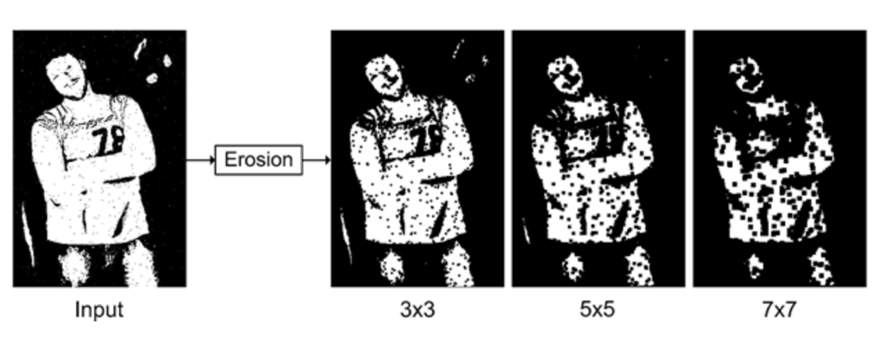

1. 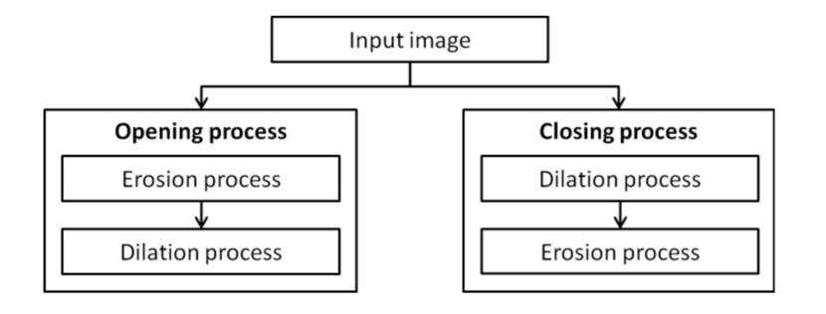Opening: Opening is the process of performing erosion followed by dilation. This operation helps in restoring the object size which gets decreased due to erosion operation. It is a beneficial operation when the original object size is important for further tasks.

|  |  |  |
| --- | --- | --- |
|  | $$g\left(x,y\right)=f\left(x,y\right)∘SE$$ | (3.1) |

|  |  |  |
| --- | --- | --- |
|  |  | (3.2) |

|  |  |  |
| --- | --- | --- |
|  |  | (3.3) |

|  |  |  |
| --- | --- | --- |
|  |  |  |
|  |  |  |
|  |  |  |
|  |  |  |

The opening operation is performed on an image, as shown in figure 3 [26], where it is evitable that after performing erosion there is a decrease in the objects size which is removed by further performing dilation.

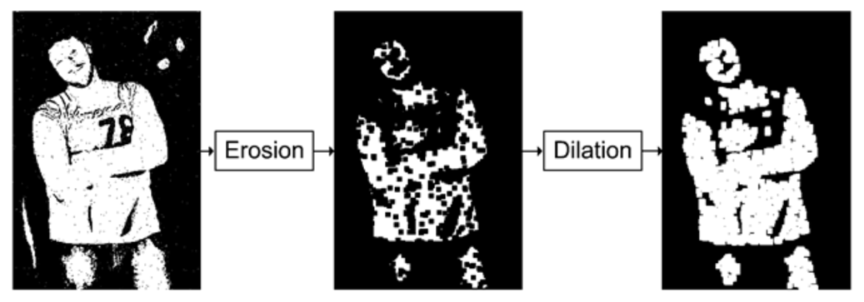

Figure 3 - Opening operation performed on a real life image

1. Closing: Closing addresses one of the common issues created due to dilation, that is, the increase in object size when it is used to fill in gaps in objects. This problem can be easily resolved by shrinking the object by following the Dilation by an Erosion. This can be mathematically stated as:

|  |  |  |
| --- | --- | --- |
|  | $$g\left(x,y\right)=f\left(x,y\right)•SE$$ | (4.1) |

|  |  |  |
| --- | --- | --- |
|  |  | (4.2) |

|  |  |  |
| --- | --- | --- |
|  |  | (4.3) |

|  |  |  |
| --- | --- | --- |
|  |  |  |
|  |  |  |
|  |  |  |
|  |  |  |

The closing operation is performed on an image, as shown in figure 4 [26], where it is evitable that after performing dilation there is an increase in the background noise objects which is removed by further performing erosion.

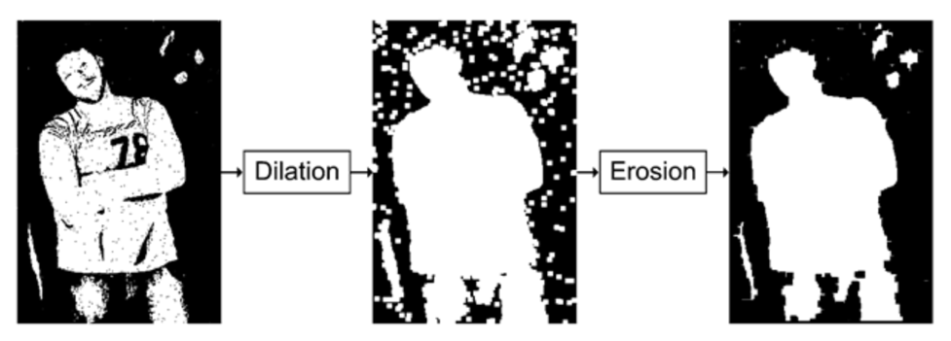

Figure 4 - Closing operation performed on a real life image

1. Edge detection: The boundary in mathematical terms can be defined as the difference between the input image and the eroded version of the image having smaller version of objects. This can be understood by the equation 5.1 shown below.

|  |  |  |
| --- | --- | --- |
|  | $$g\left(x,y\right)=f\left(x,y\right)-\left(f\left(x, y\right)⊖SE\right)$$ | (5.1) |

Figure 5 gives a practical illustration of edge detection performed on a real life binary image.

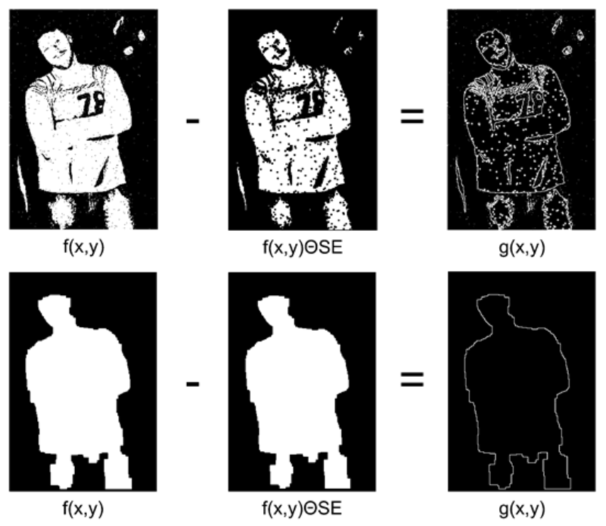

Figure 5 - A practical example of Edge Detection

1. Skew correction: An image can be asymmetric if the page is not scanned properly. Skewness of an image measures the symmetry of the image. If the page is skewed, as shown in figure 5[a], then the quality of OCR’s line segmentation can be heavily impacted. This can be improved by rotating the page so as to bring the lines at horizontal inclination, as shown in figure 5[b].

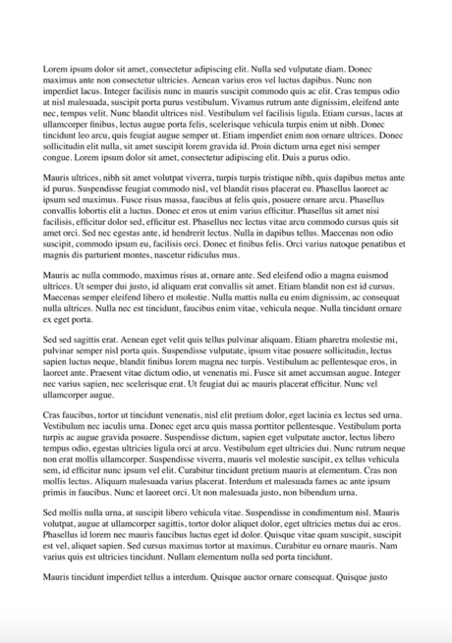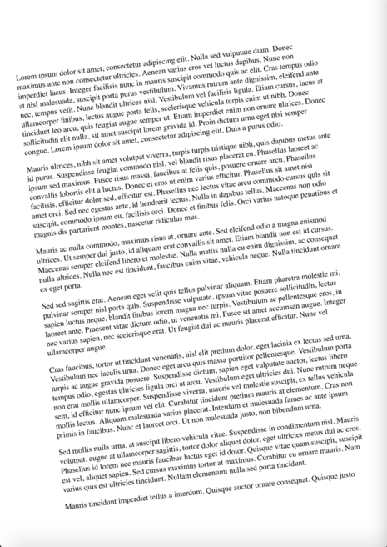

Figure 5 – Skew correction performed on a page of a book. These figures are taken from [27].

[b] Deskewed image

[a] Skewed image

## 3.7 Model Architecture

For both the OCR tools, the implementation is divided into five different parts:

* Libraries: As the first step, all the necessary libraries for our task are installed and imported in the OCR environment. The list of these libraries is further updated with the other steps of the implementation, as needed.
* Data Import: This is the basic OCR implementation step, wherein the data/image is imported from the local drive into the Integrated development environment, which in this project is Jupyter Notebook.
* Data Pre-processing: As mentioned in section 3.5, this step is important to convert the input image into multiple different pre-processed images for better OCR conversion and in-depth comparison of the tools.

* Image to text conversion: At this step, the OCR libraries are given different pre-processed images as input to carry out the process of extracting text from image.
* Error check: At this final step, the output text of all the different input images is compared with the ground truth. This helps in getting the error rates of all the images for comparison.

## 3.8 Comparison Methods

Comparing different OCR tools has always been a very challenging task due to a variety of images available with different image quality, font size, architecture etc. Due to the diversity of the dataset chosen for this task, the comparison needs be done on multiple factors. There are three major comparison methods taken into consideration for this project,

* Character Error Rate: Discussed in section 2.8.
* Word Error Rate: Discussed in section 2.9.
* Image to text conversion Time: Due to architectural different and various implementation approaches by the existing OCR tools, time taken to convert an image into text by any OCR tool is a crucial comparison factor.

The WER and CER are evaluated by calculating the Levenshtein distance (discussed in section 2.10). Wagner-Fisher Algorithm is used to calculate the Levenshtein distance (also known as the edit distance). The pseudo code of the fisher algorithm in shown below. This algorithm helps in determining how different are the two strings. Majorly there are three edit operations used in this algorithm, which are, substitution, deletion and insertion. The algorithm works by assigning different costs to each edit operations but in this experiment, the cost is set to one for each edit operation. This is done to get the maximum edit distance which is equal to the length of the longer string. The edit distance is zero when both the strings are equal.

The output error used for the comparison is:

|  |  |  |
| --- | --- | --- |
|  |  |  |
|  |  |  |
|  |  |  |

|  |
| --- |
| Algorithm 1 - Wagner - Fisher Algorithm (all operations cost equal to one) |
|  |

## 3.9 Results

The results of both the OCR tools are listed in the following table:

* Table 1: Lists the output obtained from Tesseract OCR when invoice images are given as input. The outputs are not normalised for better interpretations.
* Table 2: Lists the output obtained from Tesseract OCR when article images are given as input. The outputs are not normalised for better interpretations.
* Table 3: Lists the output obtained from Tesseract OCR when advertisement images are given as input. The outputs are not normalised for better interpretations.
* Table 4: Lists the output obtained from EasyOCR when invoice images are given as input. The outputs are not normalised for better interpretations.
* Table 5: Lists the output obtained from EasyOCR when article images are given as input. The outputs are not normalised for better interpretations.
* Table 6: Lists the output obtained from EasyOCR when advertisement images are given as input. The outputs are not normalised for better interpretations.

These tables list down the individual character error rate and word error rate as well as mean error rate for all the images. To keep the error rates simple to analyse, they have not been normalised, which means the error can go beyond 100% mark. As discussed in section 2.9, it is very common to see the error rate exceeding 100% in OCR projects.

### 3.9.1 Tesseract Output

Table 1: Tesseract invoice image output (not Normalised)

|  |  |  |  |  |  |
| --- | --- | --- | --- | --- | --- |
| Image Category | Image type | Word error rate | Mean WER | Character error rate | Mean CER |
| Invoice_image_1 | Original image | 186.49% | 106.56% | 65.23% | 45.70% |
| Thresholding image | 81.08% | 40.73% |
| Opened image | 113.51% | 53.31% |
| Canny edge image | 113.51% | 57.95% |
| Noise removed image | 89.19% | 40.40% |
| Dilated image | 105.41% | 42.38% |
| Eroded image | 56.76% | 19.87% |
|  | | | | | |
| Invoice_image_2 | Original image | 48.79% | 50.71% | 32.00% | 34.38% |
| Thresholding image | 47.42% | 31.68% |
| Opened image | 26.80% | 9.00% |
| Canny edge image | 55.67% | 26.89% |
| Noise removed image | 28.52% | 8.69% |
| Dilated image | 97.59% | 94.43% |
| Eroded image | 50.17% | 37.98% |
|  | | | | | |
| Invoice_image_3 | Original image | 125.26% | 140.30% | 42.57% | 61.97% |
| Thresholding image | 164.21% | 79.77% |
| Opened image | 108.42% | 35.22% |
| Canny edge image | 183.16% | 85.57% |
| Noise removed image | 151.58% | 57.71% |
| Dilated image | 98.95% | 84.72% |
| Eroded image | 150.53% | 48.23% |
|  | | | | | |
| Invoice_image_4 | Original image | 36.94% | 54.57% | 8.15% | 18.73% |
| Thresholding image | 42.34% | 8.83% |
| Opened image | 36.04% | 6.87% |
| Canny edge image | 87.39% | 57.61% |
| Noise removed image | 35.14% | 8.73% |
| Dilated image | 99.10% | 32.19% |
| Eroded image | 45.05% | 8.73% |

Table 2: Tesseract article image output (not Normalised)

|  |  |  |  |  |  |
| --- | --- | --- | --- | --- | --- |
| Image Category | Image type | Word error rate | Mean WER | Character error rate | Mean CER |
| Article_image_1 | Original image | 15.73% | 35.92% | 6.20% | 24.30% |
| Thresholding image | 16.38% | 6.49% |
| Opened image | 20.98% | 7.07% |
| Canny edge image | 36.61% | 17.80% |
| Noise removed image | 27.08% | 8.22% |
| Dilated image | 99.57% | 99.24% |
| Eroded image | 35.11% | 25.10% |
|  | | | | | |
| Article_image_2 | Original image | 48.79% | 50.71% | 32.00% | 34.38% |
| Thresholding image | 47.42% | 31.68% |
| Opened image | 26.80% | 9.00% |
| Canny edge image | 55.67% | 26.89% |
| Noise removed image | 28.52% | 8.69% |
| Dilated image | 97.59% | 94.43% |
| Eroded image | 50.17% | 37.98% |
|  | | | | | |
| Article_image_3 | Original image | 97.86% | 96.88% | 63.88% | 69.94% |
| Thresholding image | 96.91% | 63.63% |
| Opened image | 90.02% | 60.03% |
| Canny edge image | 107.36% | 72.91% |
| Noise removed image | 99.52% | 68.56% |
| Dilated image | 99.29% | 97.67% |
| Eroded image | 87.17% | 62.89% |
|  | | | | | |
| Article_image_4 | Original image | 34.07% | 70.36% | 10.98% | 49.20% |
| Thresholding image | 34.62% | 11.22% |
| Opened image | 54.58% | 39.56% |
| Canny edge image | 76.92% | 45.30% |
| Noise removed image | 121.25% | 80.82% |
| Dilated image | 98.17% | 94.26% |
| Eroded image | 72.89% | 62.29% |

Table 3: Tesseract advertisement image output (not Normalised)

|  |  |  |  |  |  |
| --- | --- | --- | --- | --- | --- |
| Image Category | Image type | Word error rate | Mean WER | Character error rate | Mean CER |
| Advert_image_1 | Original image | 34.64% | 76.86% | 13.44% | 56.71% |
| Thresholding image | 35.49% | 13.90% |
| Opened image | 94.20% | 83.53% |
| Canny edge image | 125.09% | 85.08% |
| Noise removed image | 53.92% | 17.51% |
| Dilated image | 99.83% | 95.44% |
| Eroded image | 94.88% | 88.09% |
|  | | | | | |
| Advert_image_2 | Original image | 27.97% | 49.80% | 11.11% | 32.38% |
| Thresholding image | 27.77% | 11.17% |
| Opened image | 46.76% | 18.24% |
| Canny edge image | 54.70% | 37.45% |
| Noise removed image | 43.84% | 27.10% |
| Dilated image | 97.49% | 91.68% |
| Eroded image | 50.10% | 29.89% |
|  | | | | | |
| Advert_image_3 | Original image | 84.19% | 104.09% | 49.97% | 70.66% |
| Thresholding image | 86.32% | 50.57% |
| Opened image | 104.27% | 69.74% |
| Canny edge image | 144.87% | 82.44% |
| Noise removed image | 116.24% | 72.64% |
| Dilated image | 98.72% | 93.59% |
| Eroded image | 94.02% | 75.66% |
|  | | | | | |
| Advert_image_4 | Original image | 40.37% | 65.40% | 9.09% | 35.94% |
| Thresholding image | 40.83% | 9.49% |
| Opened image | 61.01% | 23.86% |
| Canny edge image | 88.53% | 34.68% |
| Noise removed image | 51.38% | 15.47% |
| Dilated image | 98.62% | 93.85% |
| Eroded image | 77.06% | 65.15% |

### 3.9.2 EasyOCR Output

Table 4: EasyOCR invoice image output (not Normalised)

|  |  |  |  |  |  |
| --- | --- | --- | --- | --- | --- |
| Image Category | Image type | Word error rate | Mean WER | Character error rate | Mean CER |
| Invoice_image_1 | Original image | 243.24 % | 196.13% | 72.19 % | 58.47% |
| Thresholding image | 105.41 % | 21.19 % |
| Opened image | 97.3 % | 17.55 % |
| Canny edge image | 589.19 % | 236.09 % |
| Noise removed image | 113.51 % | 20.2 % |
| Dilated image | 124.32 % | 26.49 % |
| Eroded image | 100.0 % | 15.56 % |
|  | | | | | |
| Invoice_image_2 | Original image | 111.11 % | 177.78% | 25.87 % | 68.29% |
| Thresholding image | 100.0 % | 100.0 % |
| Opened image | 116.67 % | 25.46 % |
| Canny edge image | 544.44 % | 195.69 % |
| Noise removed image | 112.96 % | 26.49 % |
| Dilated image | 133.33 % | 70.84 % |
| Eroded image | 125.93 % | 33.68 % |
|  | | | | | |
| Invoice_image_3 | Original image | 160.0 % | 200.94% | 42.72 % | 62.94% |
| Thresholding image | 251.58 % | 89.53 % |
| Opened image | 143.16 % | 37.48 % |
| Canny edge image | 317.89 % | 107.78 % |
| Noise removed image | 174.74 % | 47.24 % |
| Dilated image | 215.79 % | 65.35 % |
| Eroded image | 143.16 % | 50.49 % |
|  | | | | | |
| Invoice_image_4 | Original image | 115.32 % | 123.81% | 17.08 % | 25.69% |
| Thresholding image | 109.01 % | 22.77 % |
| Opened image | 109.91 % | 19.63 % |
| Canny edge image | 181.08 % | 46.42 % |
| Noise removed image | 116.22 % | 21.1 % |
| Dilated image | 136.04 % | 31.31 % |
| Eroded image | 99.1 % | 21.49 % |

Table 5: EasyOCR article image output (not Normalised)

|  |  |  |  |  |  |
| --- | --- | --- | --- | --- | --- |
| Image Category | Image type | Word error rate | Mean WER | Character error rate | Mean CER |
| Article_image_1 | Original image | 101.71 % | % | 76.62 % | % |
| Thresholding image | 101.61 % | 76.82 % |
| Opened image | 102.57 % | 76.1 % |
| Canny edge image | 102.46 % | 76.61 % |
| Noise removed image | 101.82 % | 75.73 % |
| Dilated image | 99.57 % | 99.08 % |
| Eroded image | 97.0 % | 75.63 % |
|  | | | | | |
| Article_image_2 | Original image | 112.71 % | % | 78.54 % | % |
| Thresholding image | 111.0 % | 78.41 % |
| Opened image | 110.31 % | 77.64 % |
| Canny edge image | 115.12 % | 78.36 % |
| Noise removed image | 111.34 % | 77.82 % |
| Dilated image | 97.94 % | 94.57 % |
| Eroded image | 97.25 % | 76.73 % |
|  | | | | | |
| Article_image_3 | Original image | 97.86% | 96.88% | 63.88% | 69.94% |
| Thresholding image | 96.91% | 63.63% |
| Opened image | 90.02% | 60.03% |
| Canny edge image | 107.36% | 72.91% |
| Noise removed image | 99.52% | 68.56% |
| Dilated image | 99.29% | 97.67% |
| Eroded image | 87.17% | 62.89% |
|  | | | | | |
| Article_image_4 | Original image | 34.07% | 70.36% | 10.98% | 49.20% |
| Thresholding image | 34.62% | 11.22% |
| Opened image | 54.58% | 39.56% |
| Canny edge image | 76.92% | 45.30% |
| Noise removed image | 121.25% | 80.82% |
| Dilated image | 98.17% | 94.26% |
| Eroded image | 72.89% | 62.29% |

**Chapter 4**

# Critical Evaluation

This chapter briefly discusses the results obtained from this experiment, as performed in Chapter 3. In section 4.1, summarizes the results of all the OCR tools on different parameters. While section 4.2 talks about the limitations of all the OCR tools.

## 4.1 Discussion of Results

This section evaluates the results obtained by this experiment in Chapter 3.

## 4.2 Limitations of OCR tools

According to image quality and page structure, the output of OCR tools differ a lot. These differences for every OCR tool are listed below.

### 4.2.1 Tesseract

* Tesseract gives lower accuracy when the segmentation between foreground and background image is less evitable.
* Even with a slight disorientation or skewness, the output gets affected to a great extent. It works best only with clean and properly scanned images.
* It cannot distinguish between characters and numbers, as in the experiment it was difficult to distinguish between ‘Z’ and ‘2’, though it performs well with characters rather than numbers. This problem can be solved by using the Tesseract blacklist feature but this will eliminate the number from the conversion list of characters and numbers.
* For documents having two different columns having lesser whitespace, tesseract merges them and does not recognise those columns separately.
* It does not give any information about the language of the input document making it difficult to assign any specific language to the tesseract model. Due to this limitation, the experiment needs to divided in two different parts; by getting the language used in part one and then performing the OCR in part two.

### 4.2.2 EasyOCR

* EasyOCR performs much slower on CPU and requires GPU for better performance. Making it a costly tool in terms of hardware needs even after being an open source tool.
* EasyOCR recognises numbers better than characters making it a bad choice for images containing articles or paragraphs.
* It does not provide much of configurational changes, due to which it becomes difficult to make good operational changes in the tool.

**Chapter 5**

# Conclusions and Future Work

This chapter of the thesis focuses on the outcome and future work of this project. Section 5.1 gives a brief summary of the results, while section 5.2 discuss the limitations of this project. It concludes with the section 5.3 where the future work of this project is discussed briefly.

## 5.1 Summary

## 

## 5.2 Limitations

The thesis has covered all the necessary aspects of the comparison. The outcomes of the experiment carried out in the thesis are dependent on some limitations:

* The most basic limitation of this experiment is the hardware limitation. OCR tools require a lot of processing and memory space as the dataset is large and multiple training sets are required to create the model. Even with a good hardware support, any OCR tool needs at least a few minutes to see the output of a single image. This experiment is carried on a small budget laptop due to which the dataset used is small in size.
* The OCR tools compared in this experiment are limited to three but there can be many different pairs of OCR tools that can be compared. Due to market availability of various OCR tools, it is out of scope of this thesis to compare them all. Moreover, every OCR tool needs different development environment, making it difficult to setup on a small budget laptop.
* OCR output is highly dependent on the input data language, as the structure of writing differs for every language. Due to this structural difference, the error rate and accuracy also vary a lot. Example the words written in Chinese language are difficult to recognise and translate due to less space between words, whereas English language is structurally simple to read and write as the words have space, making it much easier for OCR tools to recognise different words. This experiment is limited to a single language, that is, French and other languages are not taken into consideration.
* There can be multiple factors on which all the features of any OCR tool can be compared but it is difficult to use all those factors for comparation. To limit the project due to specific timeline, only the most important features are compared which can easily help in setting the OCR tools apart.
* Finally, the dataset used for the comparison of OCR tools in limited in size but enough to create a diversity of input images. The size of the dataset is limited by taking a fixed number of input images.

## 5.3 Future Work

There are various changes and improvements that can be made to this experiment. These improvements can lead to a much improved accuracy and lesser error rates.

**Use of Heavy Machine**

It is important to have a good hardware for OCR project. Since this project is restricted in hardware usage, it is a good idea to perform this experiment on a better hardware. This will not only help in saving time but will also help in giving more space for the OCR tools to perform specific operations.

**Extending to paid OCR tools**

There are many OCR tools available in the market in both paid and unpaid category, with a very high user base in both the categories. Due to budget constraints and high cost of paid OCR tools, this experiment compares only the open-sourced OCR tools. To have a better comparison, it is worth adding the OCR tools that are paid in the comparison list. This will give a good understanding of both paid and unpaid OCR tools as well as help in understanding if it is worth buying a paid tool.

**Trying on more input languages**

Since OCR tools have a worldwide usage, it is important to test them on texts from different languages. Adding more input data with various languages will give much better comparison results.

**Using more features to compare**

This thesis limits the features that are compared to state the best OCR tool. Adding more features to be compared in the list will give a better justification of the tool that should be used depending on the input data. This will ultimately result in a deeper and better comparison of all the tools.

**Using Big Data**

The dataset to be used for OCR is large in size majorly because the datatype of the data is image. Using big data technologies to store and retrieve the data can help in managing the data source required to perform OCR in an efficient way, making a more accurate average output.

# References

[1] Hardesty, L. (2017). *Explained: Neural networks*. [online] MIT News. Available at: <https://news.mit.edu/2017/explained-neural-networks-deep-learning-0414>.

[2] Rosenblatt, F. (1958). The perceptron: A probabilistic model for information storage and organization in the brain. *Psychological Review*, 65(6), pp.386–408.

‌[3] Fukushima, K. (1980). Neocognitron: A self-organizing neural network model for a mechanism of pattern recognition unaffected by shift in position. *Biological Cybernetics*, 36(4), pp.193–202.

‌[4] Rosenblatt, F. (1962). *Principles of neurodynamics; perceptrons and the theory of brain mechanisms.* Washingotn, D.C., Spartan Books.

‌[5] Kabrisky, M. (1966). *A proposed model for visual information processing in the human brain*. Urbana.

[6] Lecun, Y., Bottou, L., Bengio, Y. and Haffner, P. (1998). Gradient-based learning applied to document recognition. *Proceedings of the IEEE*, 86(11), pp.2278–2324.

[7] Hopfield, J.J. (1982). Neural networks and physical systems with emergent collective computational abilities. *Proceedings of the National Academy of Sciences*, [online] 79(8), pp.2554–2558. Available at: <https://www.pnas.org/content/79/8/2554> [Accessed 1 Aug. 2019].

[8] Hochreiter, S. and Schmidhuber, J. (1997). Long Short-Term Memory. *Neural Computation*, 9(8), pp.1735–1780.

‌[9] Baek, Y., Lee, B., Han, D., Yun, S. and Lee, H. (2019). *Character Region Awareness for Text Detection*. [online] . Available at: <https://arxiv.org/pdf/1904.01941.pdf> [Accessed 12 Aug. 2021].

[10] Shi, B., Bai, X. and Yao, C. (2017). An End-to-End Trainable Neural Network for Image-Based Sequence Recognition and Its Application to Scene Text Recognition. *IEEE Transactions on Pattern Analysis and Machine Intelligence*, [online] 39(11), pp.2298–2304. Available at: <https://arxiv.org/pdf/1507.05717.pdf> [Accessed 6 Apr. 2020].

[11] S, V. and A, S. (2015). Performance Comparison of OCR Tools. *International Journal of UbiComp*, 6(3), pp.19–30.

‌[12] Dhiman, S. and Singh, A. (2013). Tesseract Vs Gocr A Comparative Study. *International Journal of Recent Technology and Engineering (IJRTE)*, [online] (4), pp.2277–3878. Available at: https://www.ijrte.org/wp-content/uploads/papers/v2i4/D0788092413.pdf [Accessed 14 Aug. 2021].

[13] Heliński, M., Kmieciak, M. and Parkoła, T. (2012). *Report on the comparison of Tesseract and ABBYY FineReader OCR engines*. [online] . Available at: http://lib.psnc.pl/Content/358/PSNC_Tesseract-FineReader-report.pdf.

‌[14] Graves, A., Ch, A., Fernández, S., Gomez, F., Schmidhuber, J. and Ch, J. (2006). *Connectionist Temporal Classification: Labelling Unsegmented Sequence Data with Recurrent Neural Networks*. [online] . Available at: https://www.cs.toronto.edu/~graves/icml_2006.pdf.

‌[15] He, K., Zhang, X., Ren, S. and Sun, J. (2015). *Deep Residual Learning for Image Recognition*. [online] . Available at: https://arxiv.org/pdf/1512.03385.pdf.

‌[16] Holley, R. (2008). How Good Can It Get? Analysing and Improving OCR Accuracy in Large Scale Historic Newspaper Digitisation Programs. [online] 15. Available at: http://www.nla.gov.au/ndp/project_details/documents/ANDP_HowGoodCanitGet.pdf.

[17] B. And. Levenstein (1965). *В. И. Левенштейн, “Двоичные коды с исправлением выпадений, вставок и замещений символов”, Докл. АН СССР, 163:4 (1965), 845–848*. [online] www.mathnet.ru. Available at: http://www.mathnet.ru/links/765258e84f567bc0755d492983f5e1ba/dan31411.pdf [Accessed 17 Aug. 2021].

[18] MIT, L. (2001). *Raymond Kurzweil | Lemelson*. [online] lemelson.mit.edu. Available at: https://lemelson.mit.edu/award-winners/raymond-kurzweil [Accessed 19 Aug. 2021].

‌[19] Grandviewresearch.com. (2019). *Optical Character Recognition Market | OCR Industry Report, 2019-2025*. [online] Available at: https://www.grandviewresearch.com/industry-analysis/optical-character-recognition-market.

[20] Singh, A., Bacchuwar, K. and Bhasin, A. (2012). A Survey of OCR Applications. *International Journal of Machine Learning and Computing*, pp.314–318.

[21] Ganis, M.D., Wilson, C.L. and Blue, J.L. (1998). Neural network-based systems for handprint OCR applications. *IEEE Transactions on Image Processing*, 7(8), pp.1097–1112.

[22] Perkel, J.M. (2018). Why Jupyter is data scientists’ computational notebook of choice. *Nature*, 563(7729), pp.145–146.

[23] D, H.J. (2007). Matplotlib: A 2D graphics environment. *Computing in Science & Engineering*, 9, pp.90–95.

[24] Neuendorffer, S. (2019). *CompuServe GIF Image Format*. [online] Berkeley.edu. Available at: <https://ptolemy.berkeley.edu/eecs20/sidebars/images/gif.html>.

[25] “Improving the Quality of the Output.” *Tessdoc*, tesseract-ocr.github.io/tessdoc/ImproveQuality. Accessed 12 Sept. 2021.

‌[26] “Morphology (Introduction to Video and Image Processing) Part 2.” *What-When-How.com*, what-when-how.com/introduction-to-video-and-image-processing/morphology-introduction-to-video-and-image-processing-part-2/. Accessed 13 Sept. 2021.

‌

[27] Ertuna, Leo. “How to Automatically Deskew (Straighten) a Text Image Using OpenCV.” *Medium*, 6 Aug. 2021, becominghuman.ai/how-to-automatically-deskew-straighten-a-text-image-using-opencv-a0c30aed83df. Accessed 14 Sept. 2021.

‌

[28] Krizhevsky, Alex, et al. “ImageNet Classification with Deep Convolutional Neural Networks.” *Communications of the ACM*, vol. 60, no. 6, 24 May 2017, pp. 84–90, 10.1145/3065386.

‌

[29] Simonyan, Karen, and Andrew Zisserman. *Published as a Conference Paper at ICLR 2015 VERY DEEP CONVOLUTIONAL NETWORKS for LARGE-SCALE IMAGE RECOGNITION*. 2015.

‌

‌

‌

‌

‌

**Appendix A**

# Input Images

The experiment uses multiple different images with varying data structure. These images also have different capture quality. To give a better understanding of the images used in this project, they are attached in this section.

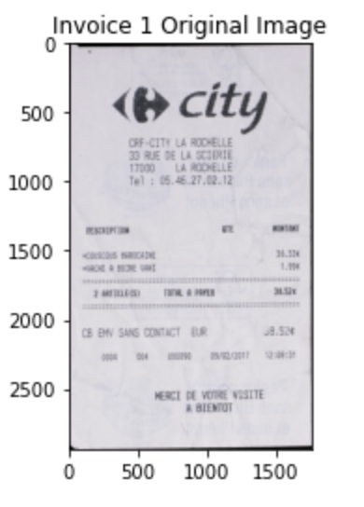

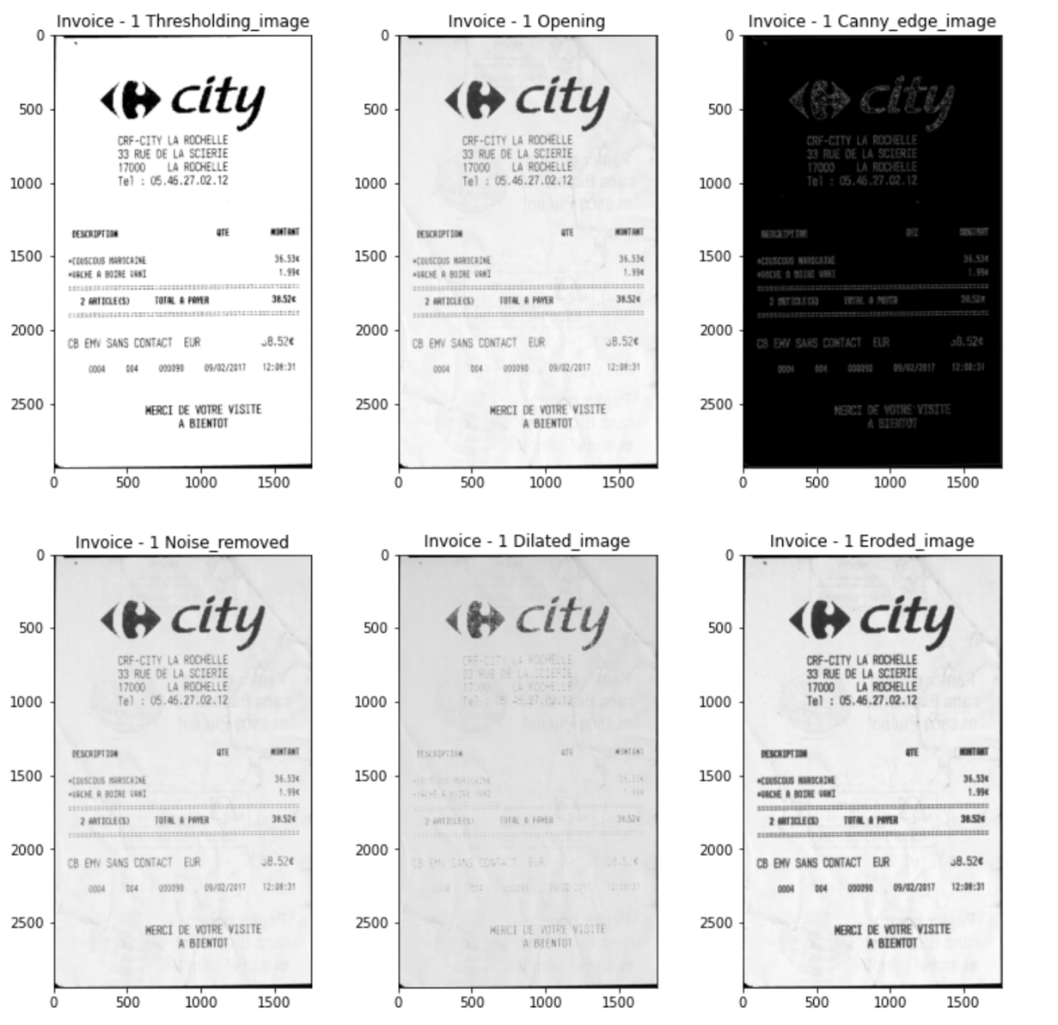

Figure 12 - Invoice Image 1

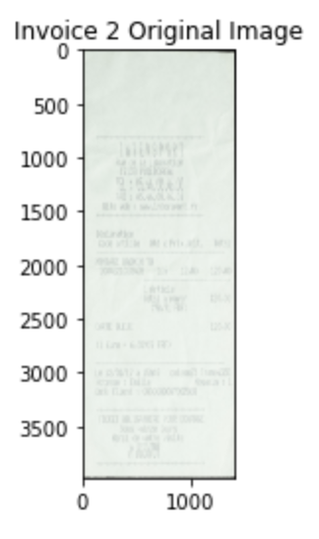

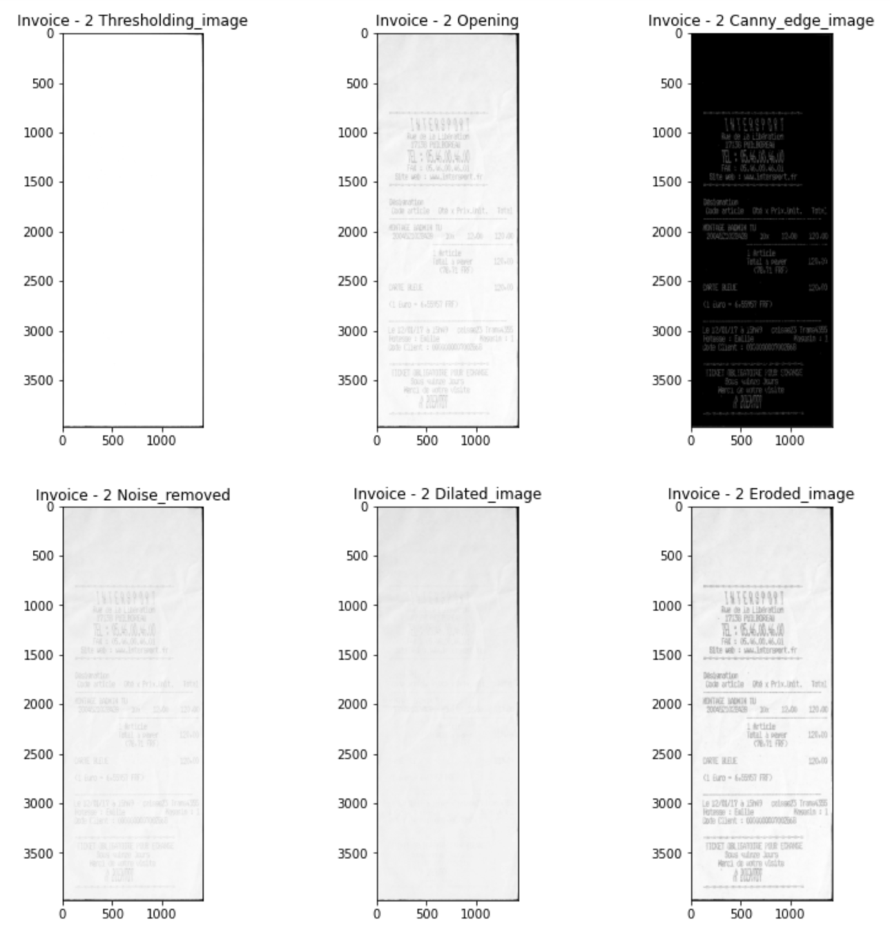

Figure 13 - Invoice Image 2

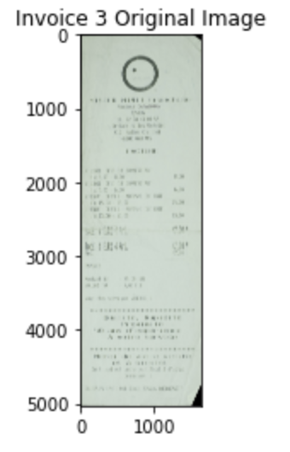

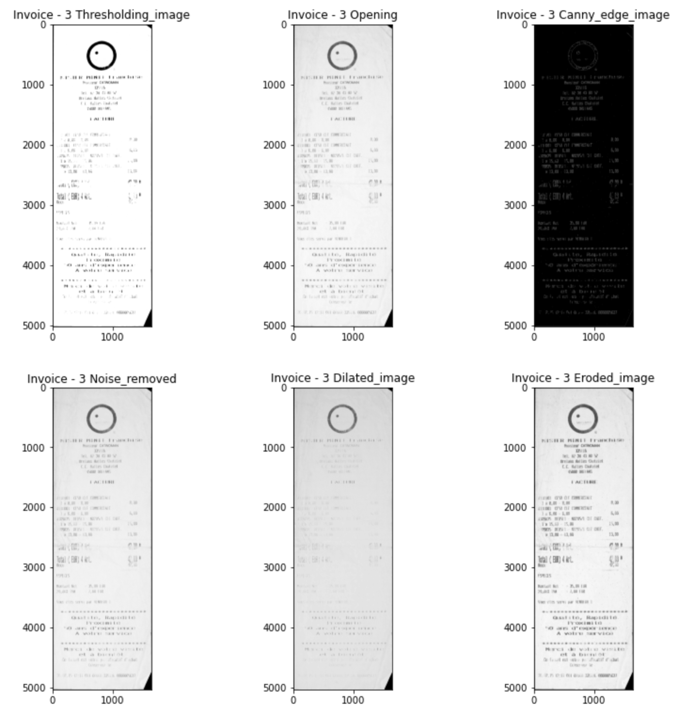

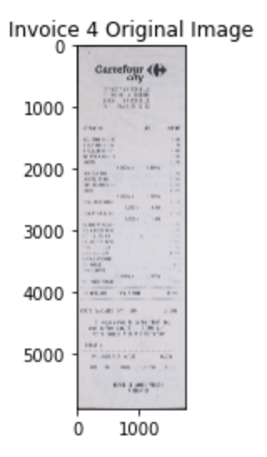

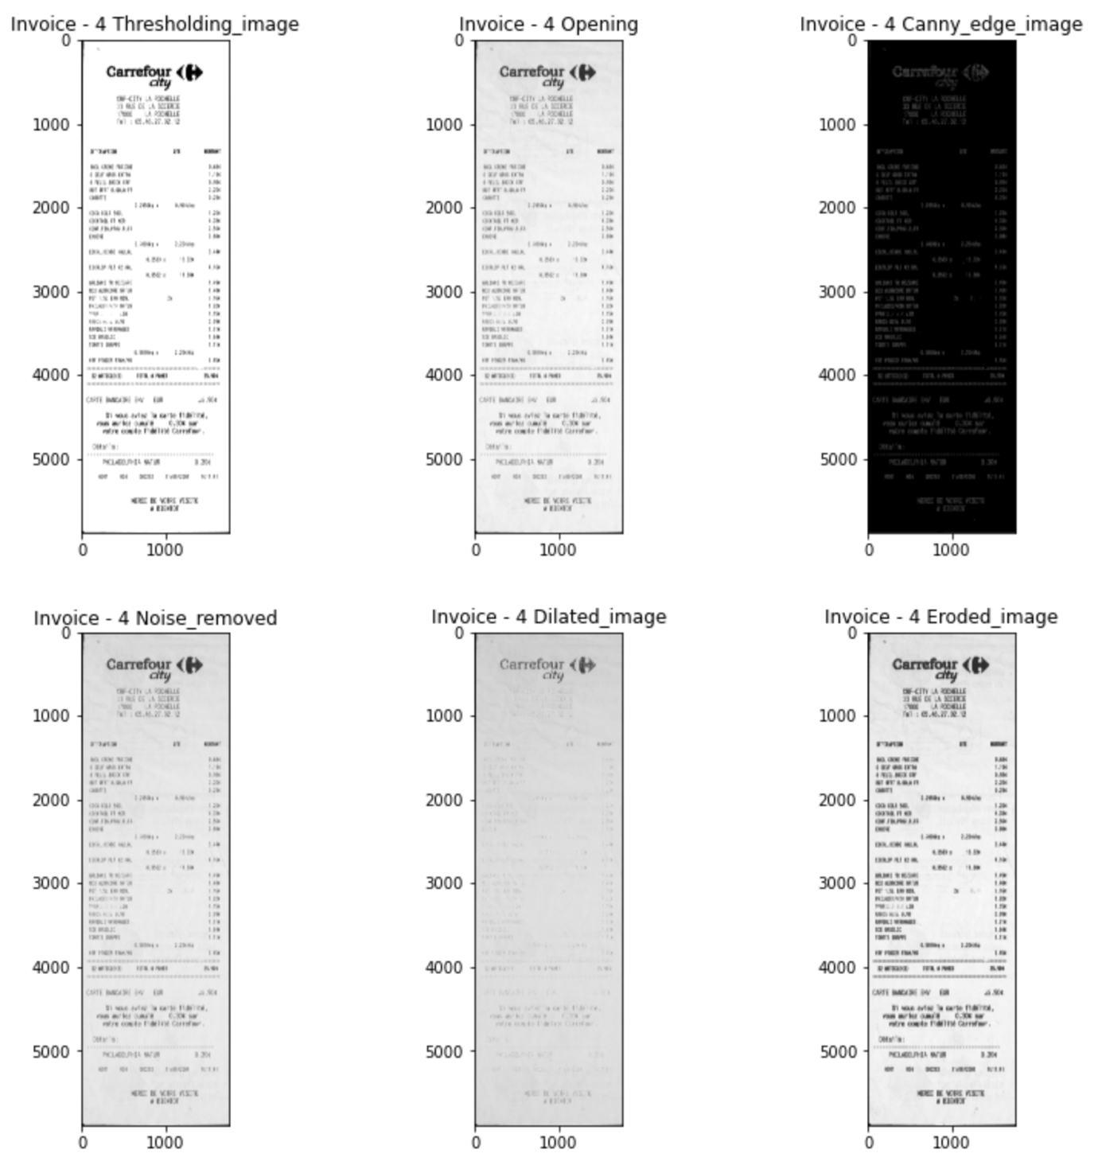

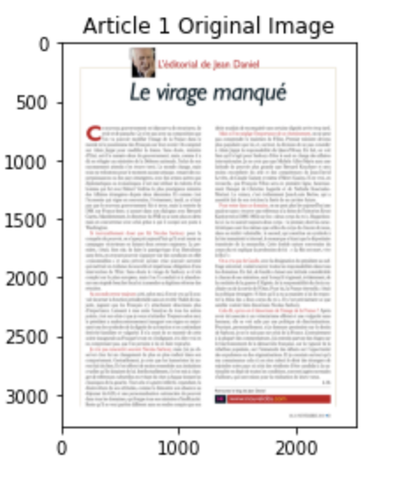

Figure 8 – Article Image 1

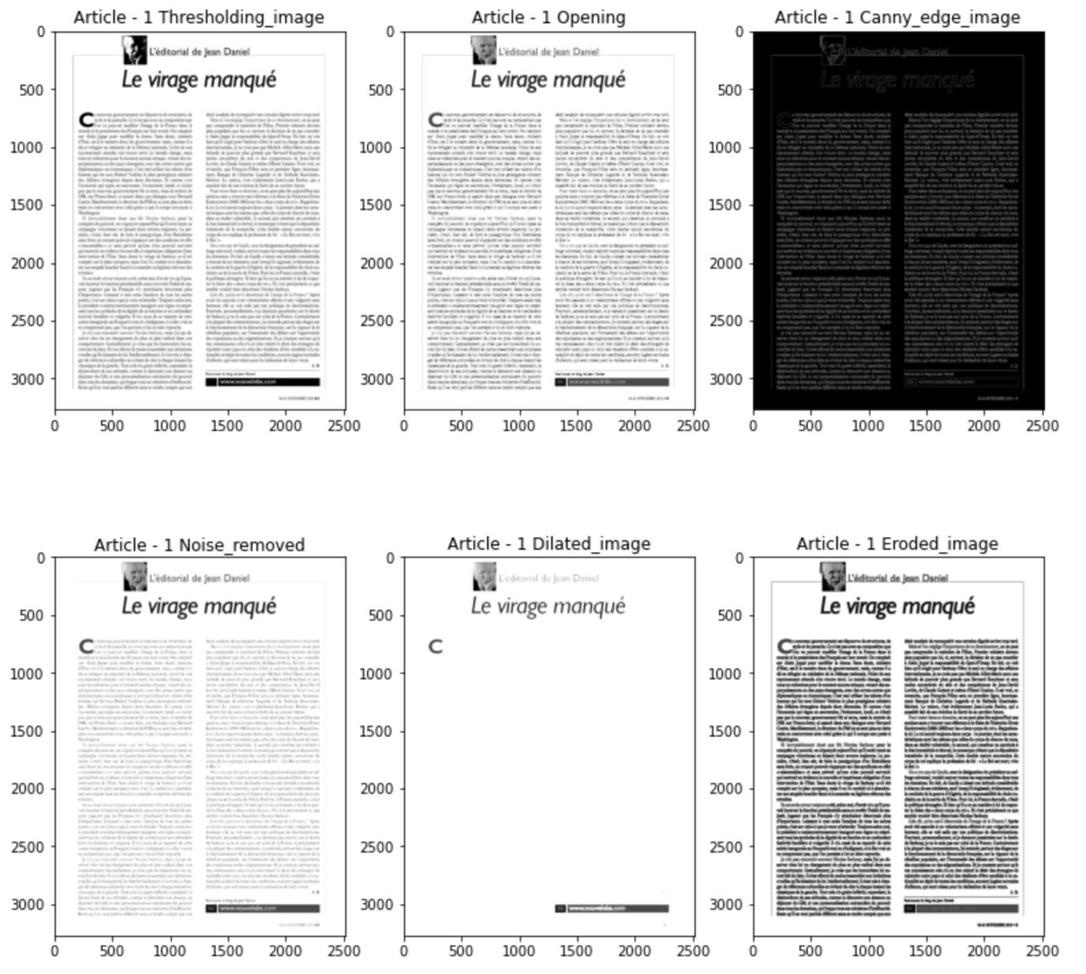

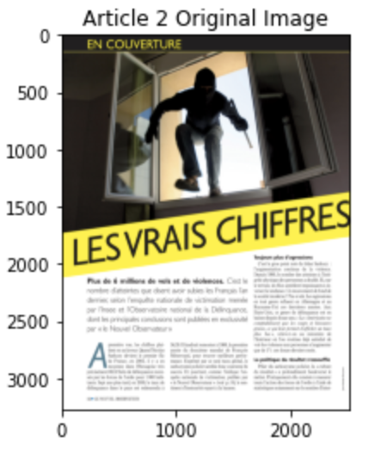

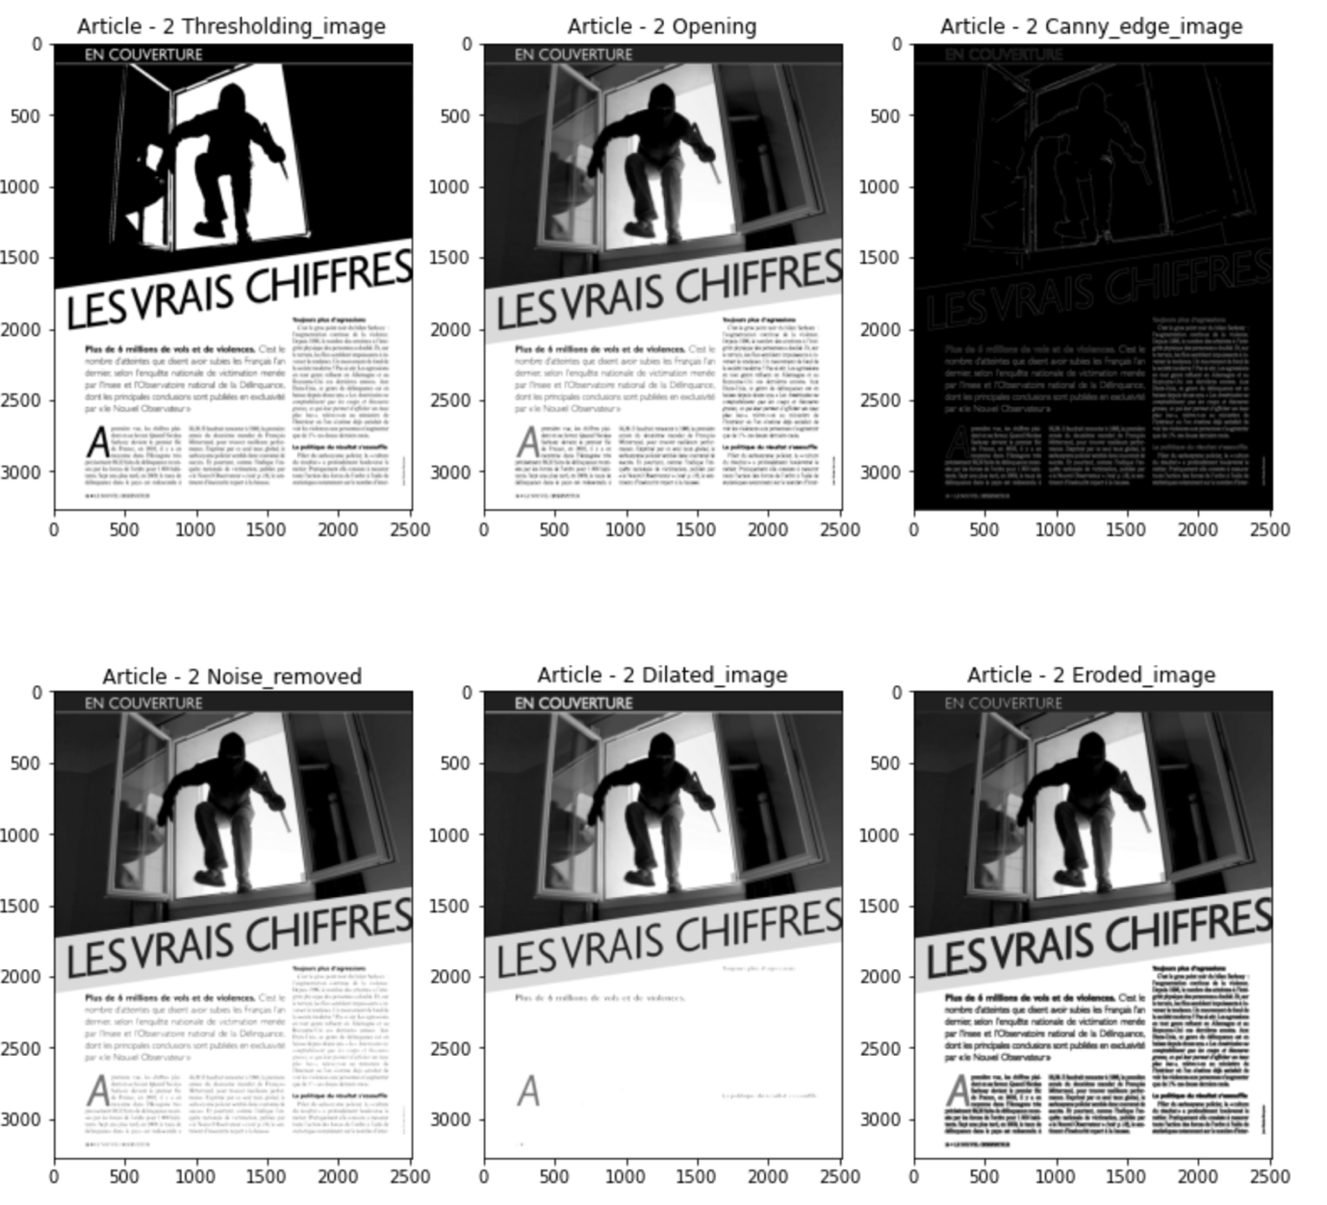

Figure 9 - Article Image 2

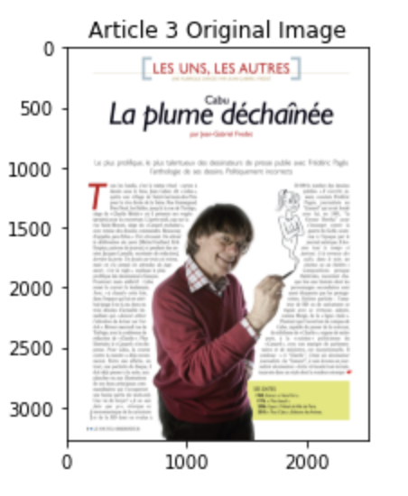

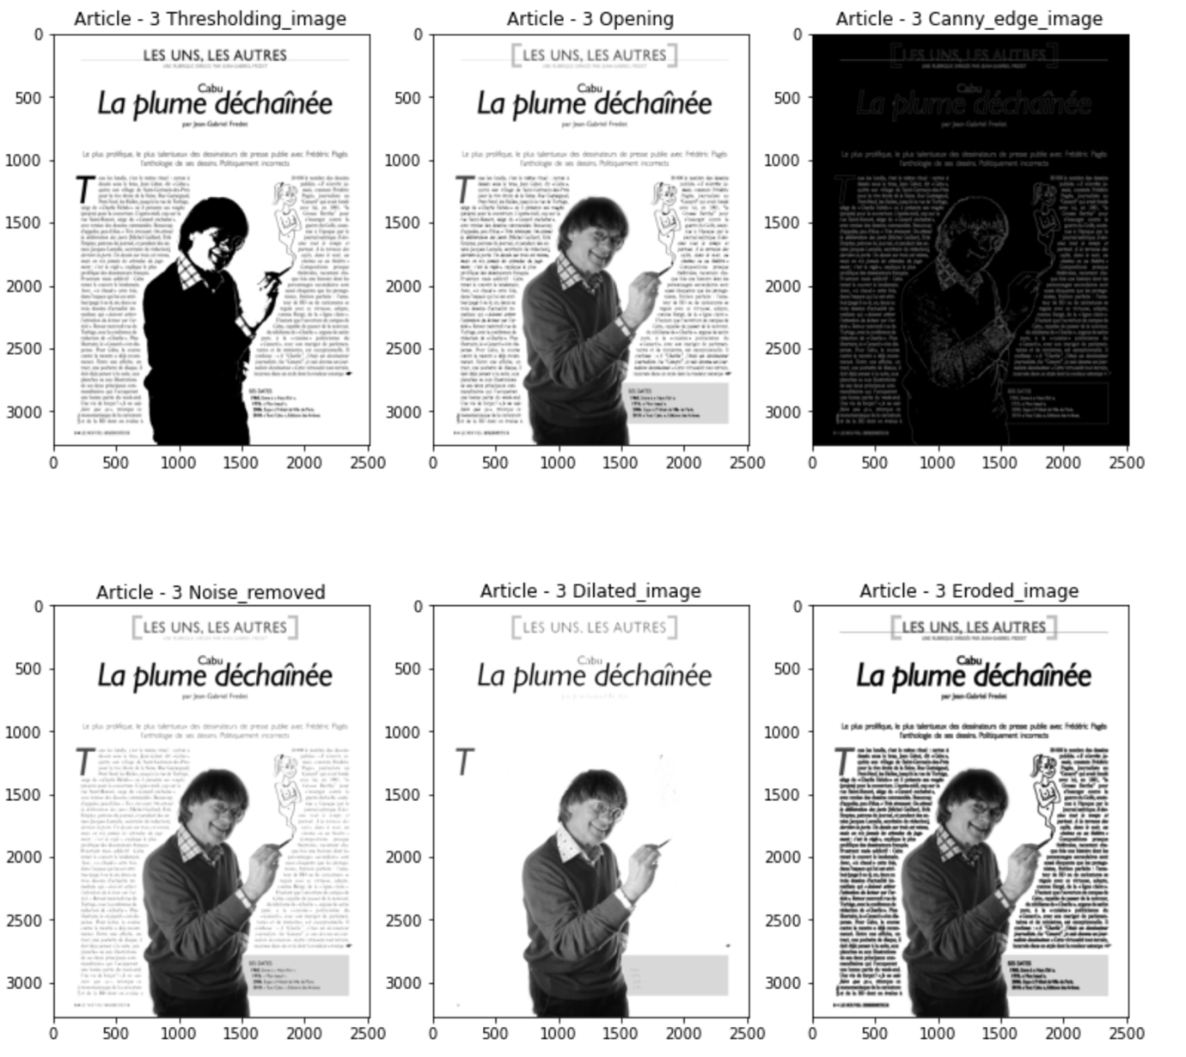

Figure 10 - Article Image 3

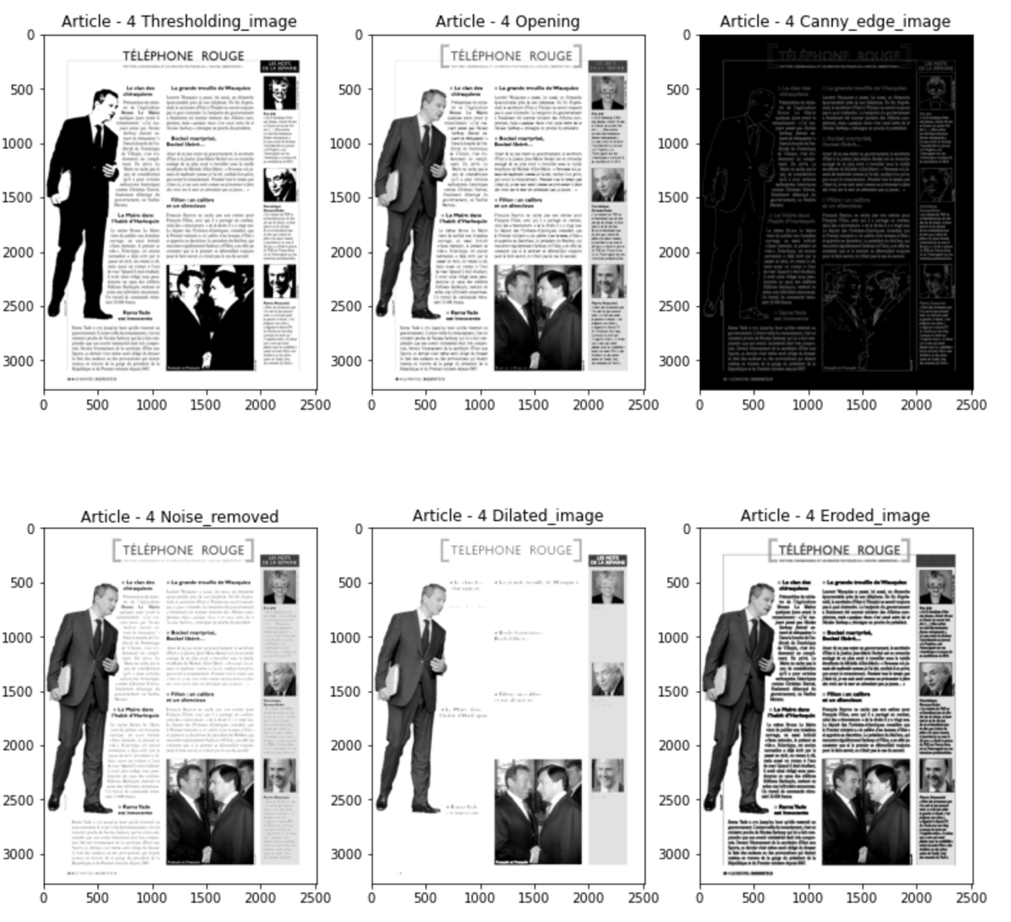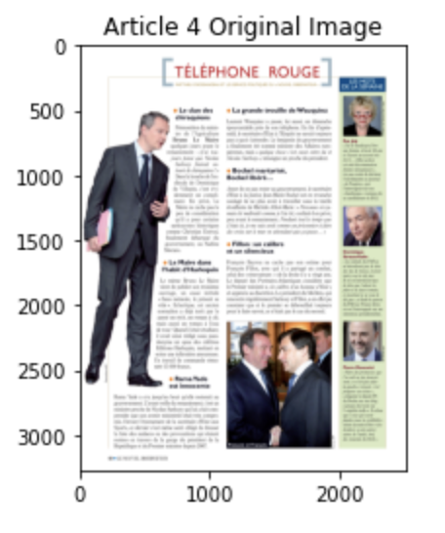

Figure 11 - Article Image 4

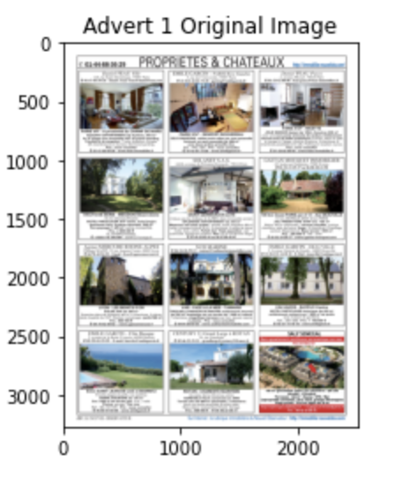

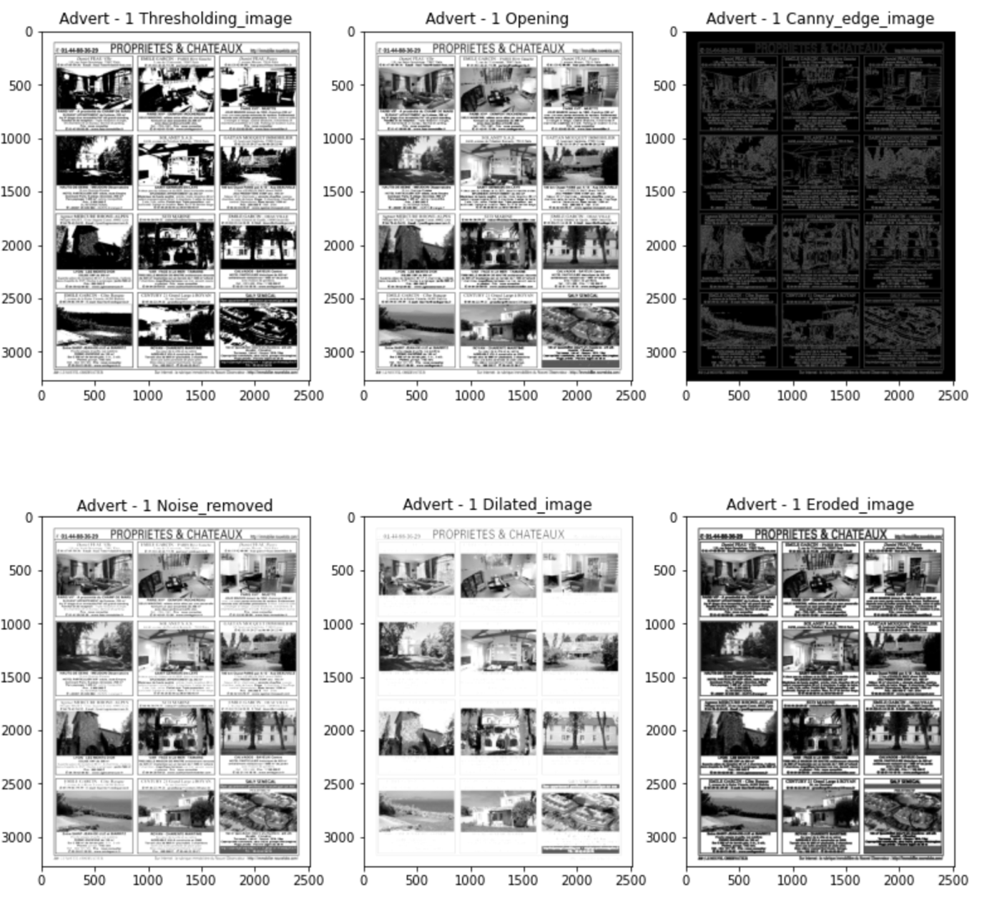

Figure 12 - Advertisement Image 1

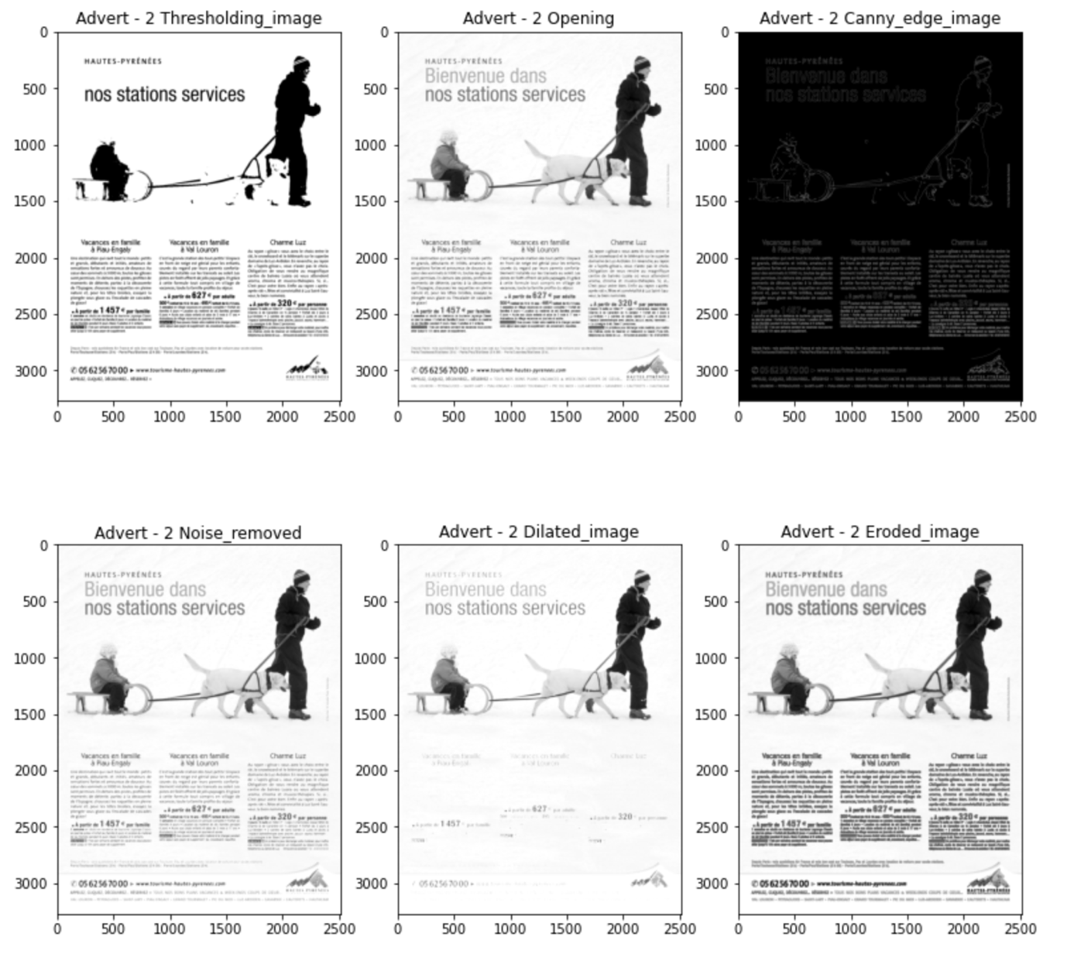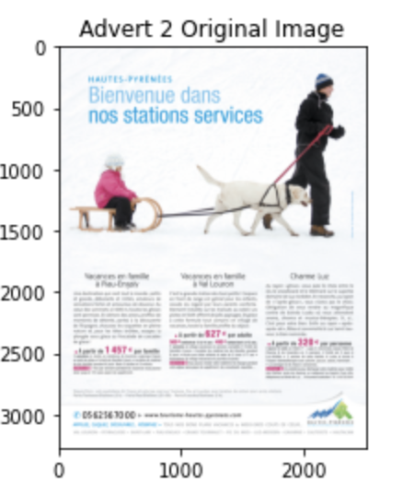

Figure 13 - Advertisement Image 2

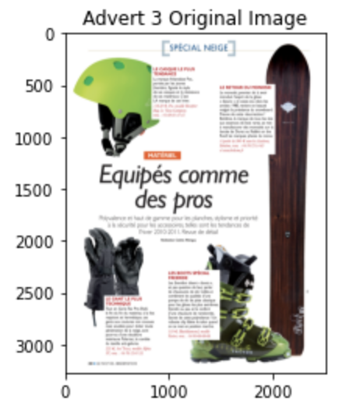

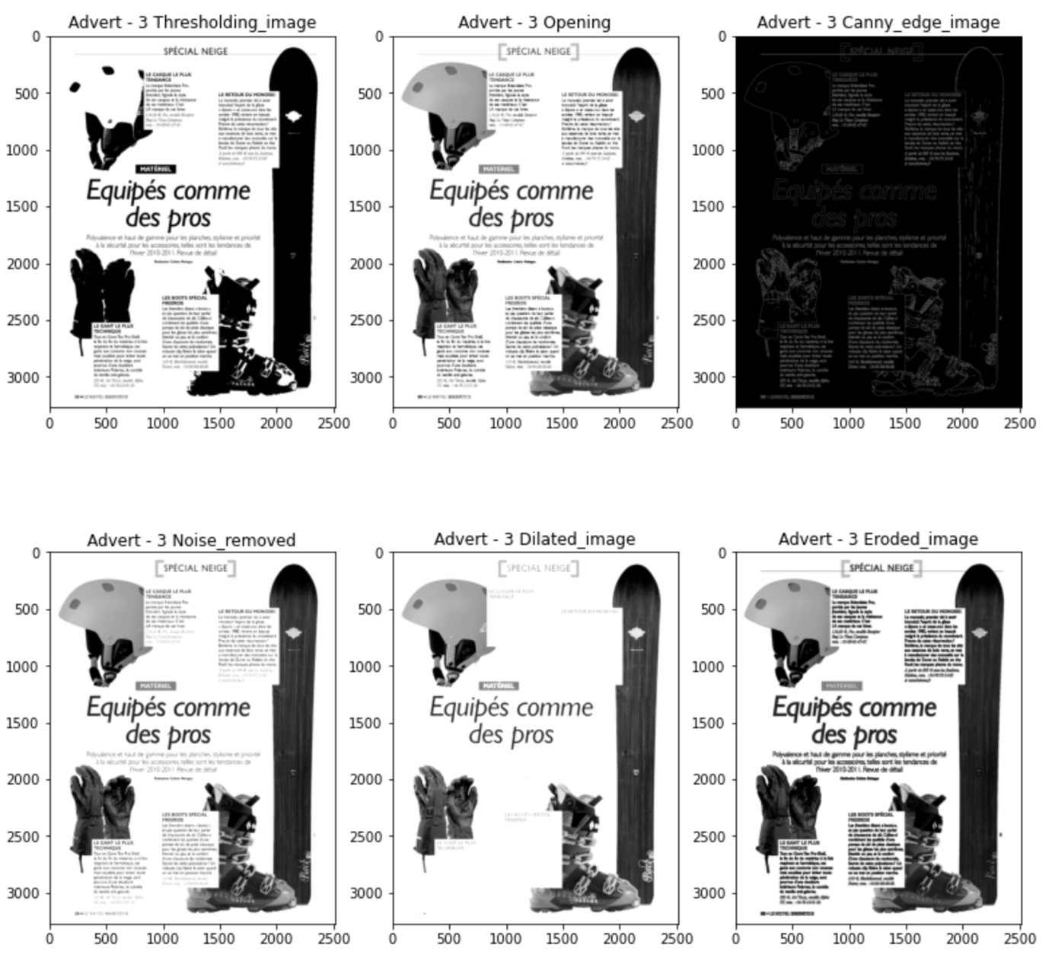

Figure 14 - Advertisement Image 3

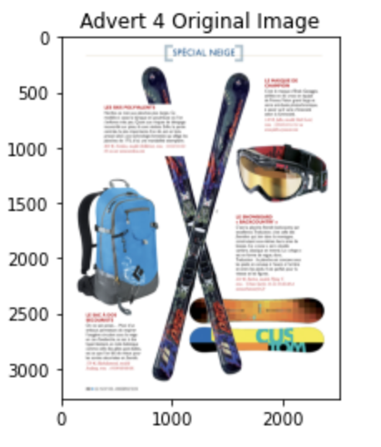

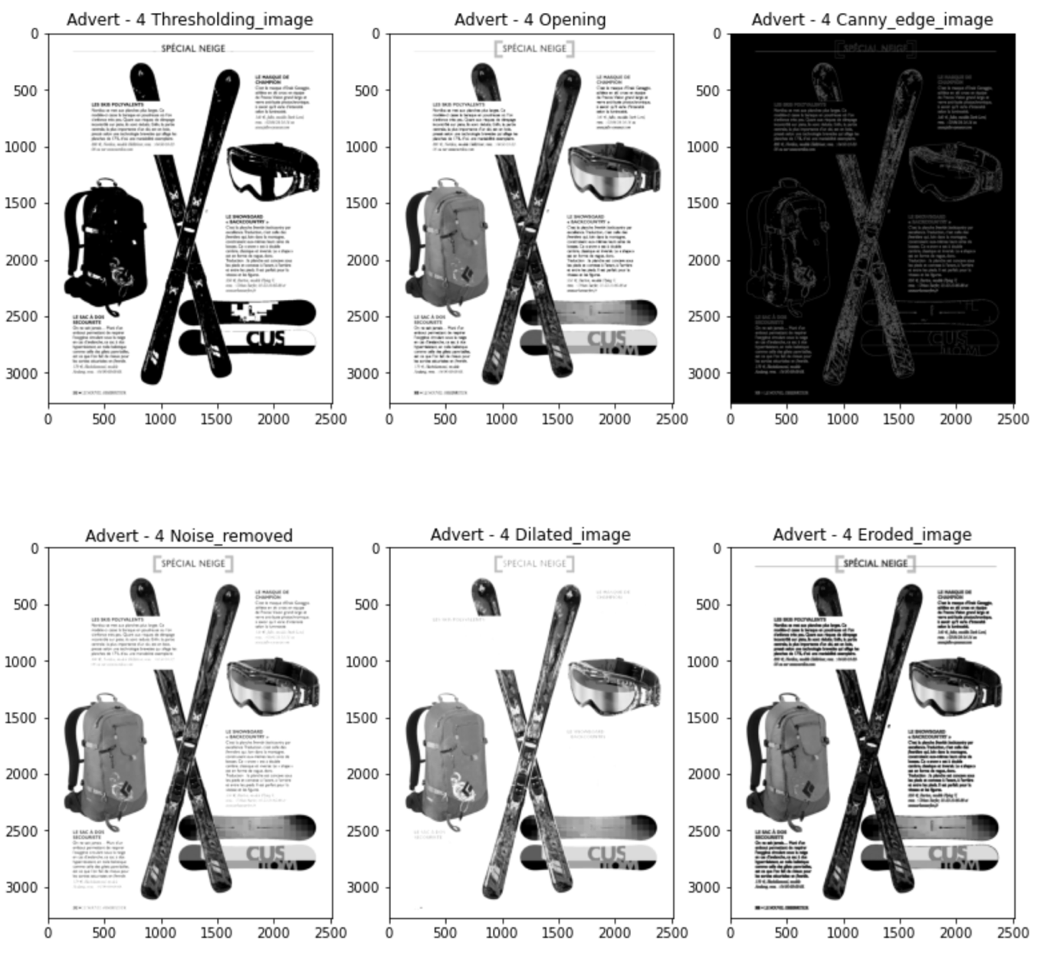

Figure 15 - Advertisement Image 4